Pre-Calculus 11  ***2.1 PART 2: SPECIAL TRIANGLES HOMEWORK***

1. State the exact value of each ratio
   1. sin 30˚ b. cos 60˚ c. tan 45˚ d. sin 45˚

e. cos 45˚ f. tan 30˚ g. sin 60˚ h. cos 30˚

1. Determine the value of θ.
   1.  b.  c.  d. 

e.  f.  g.  h. 

1. Simplify each
   1.  b.  c.  d.  e. 
2. Determine the exact value of x and y.
   1. b. c.

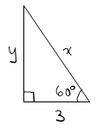

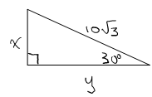

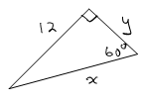

1. A guy wire is fastened 6 metres from the base of a flag pole. Determine the length of the guy wire and how far up the flag pole it is fastened.

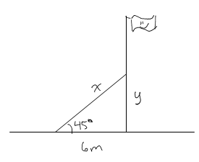

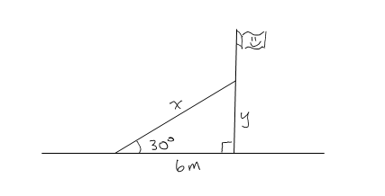

* 1. b.

1. Rhombus *ABCD* has sides of length 10cm. If the length of the diagonal of *AC* is also 10 cm, determine the length of the diagonal *BD*.

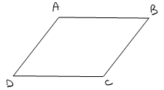

***Answers***

1a.  b.  c. 1 d.  e.  f.  g.  h. 

2a. 45˚ b. 60˚ c. 45˚ d. 60˚ e. 45˚ f. 30˚ g. 60˚ h. 30˚

3a.  b.  c.  d.  e. 7

4a. x = 6 y =  b. x = or  y = or c. x =  y = 15

5a. x = orm y = orm b. x = m y = 6m

6. cm