Physics 11
Work & Power Worksheet
40 marks
- Calculate the work done on moving a 25 kg box a distance of 3.7 m by an applied horizontal force of 65 N? (2 marks)
65 N

3.7 m

- A 125 kg sled is lifted to the top of a 23 m high hill.
  - What is the work done in lifting the sled? (3marks)
  - A time of 15.9 s is required to lift the sled to the top of the hill. How much power does this require? (2 marks)
- In 1979 the human powered Gossamer Albatross flew across the English Channel. The pedaling pilot averaged 190 W over the distance. 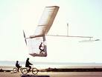 If the pilot’s power was used to lift a 110 kg mass, to what height would he lift the mass in a time of 25 s? (3 marks)
- A 2.5 hp (1 hp = 744 W) motor is used to power a hoist to lift a 1700 kg car 1.86 m above the garage floor.
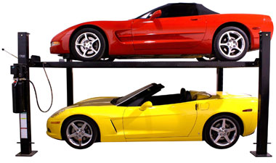
  - How much time does it take the hoist to lift the car? (3 marks)
  - The hoist slowly lowers the car back down to the ground. How much work does the hoist motor do in lowering the car? (2 marks)

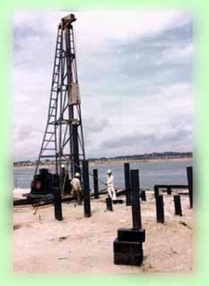
- A pile driver is used to drive large piles in to soft ground to create a solid foundation for a building. The pile driver has a mass of 450 kg and is lifted to a height of 2.5 m above the pile and is then allowed to fall striking the pile. The ground offers a resistance of 2.0 x 10⁵ N of force against the push of the pile.
  - How far does the pile drive push the pile into the ground with each strike? (4 marks)
  - How many strikes would the pile driver have to make to drive 50 piles 7.5 m into the ground? (3 marks)
- Many mountain roads are built so they spiral around the mountain rather than go straight up towards the peak. Explain why such a spiral design is beneficial for vehicles?
(2 marks)
- A 1500 kg car accelerates from rest to 10.0 m/s in 3.00 s.
  - Find the work done on the car in this time period. (4 marks)
  - Find the average power delivered by the engine in this time interval. (2 marks)
- The Harrier Jet is a vertical takeoff and landing aircraft. What is the work done when the 8000 kg plane accelerates upwards at 1.0 m/s² for a distance of 30 m starting from rest? (Hint: Do not forget to include the weight of the plane in your calculation.) (4 marks)
- In fighting a fire a pumper fire truck must be able to list 18000 kg of water to a height of 27 m in a time of 35 s. 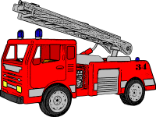What is the power of the pump in the fire truck pumper? (3 marks)
- A 500 hp Mustang is able to push this 1750 kg car down a 410 m drag strip in a time of 11.5 s.
  - What is the work done by the car? (3 marks)
  - How is the average force during the car’s motion? (2 marks)

