**Systems of Linear Equations Name: ___________**

C1 Assignment - Solving Systems of Equations Graphically

1. For each question, graph both equations on the same grid and locate the intersection point.

 $a) y=\frac{1}{3}x+1 ; y=2x-4$ b) $y=\frac{1}{2}x+4 ; 5x+4y+12=0$



$c) y= -\frac{4}{3}x+5 ; x=3$ $d) y=-x-1 ; y=-4$

1. Solve each system of linear equations graphically and then verify the solution algebraically.

a)  b)  c) 

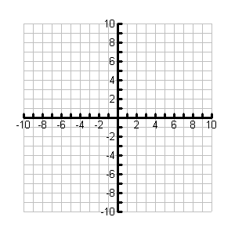

Solution is ____________ Solution is ____________ Solution is ____________

Verify Solution: Verify Solution: Verify Solution:

1. You have just started a new job and have been given the following options for your weekly wage. Option 1 is an hourly rate of $10/hr with a weekly salary of $150. Option 2 is an hourly rate of $15/hr with a weekly salary of $50.

Make a System of Linear Equations to represent your wage options.

Explain which option would be better depending on how many hours you work in a week. (Please use a table of values and a graph in your explanation)

