**Systems of Linear Equations Name: ________________**

C2 Assignment – Number of Solutions to a System

1. Predict the number of solutions for each system of linear equations. Justify your answers.

a)  b) 

c)  d) 

1. Graph each system of linear equations and indicate the number of solutions.

a)  b)  c) 

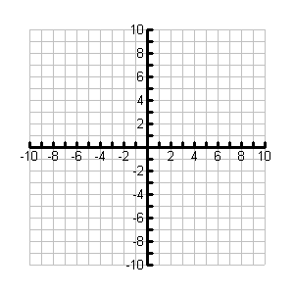

1. A line is defined by the equation . Determine the equation of a second line such that the system of linear equations has…

a) no solution

b) an infinite number of solutions

c) one solution

1. Service charges of two cell phone companies consist of a constant flat rate and a rate per minute of use. If *C* represent the total cost and *m* represents the rate per minute, use values of your choice to create a system of linear equations that expresses the service charges of the companies where the system has

a) one solution

b) no solution

c) an infinite number of solutions