**Key Terms and Concepts**

gravitational force

weight

gravitational mass

action-at-a-distance force

field

gravitational field

gravitational field

strength

torsion balance

true weight

apparent weight

free fall

true weightlessness

4.1

1. What is the Newtonian weight of a 55 kg man (Patrick O’Connor) on earth? (4 marks)

2. If planet x has a radius of 2.2x10^5 m and has a gravitational acceleration of 6.2m/s^2 what would be the gravitational acceleration affecting Patrick if he was in 6.6x10^5m away from planet x’s surface.



4.2

1. You will have to draw and explain how the torsion balance works and what it was used for. (4 marks)
2. Mount Squirrel in the imaginary place and can be found on planet Brayden is 8989 m above sea level, and is the highest peak in Rodent Valley. Planet Brayden has a mass of 7.97 x10^24 kg and planet Brayden’s equatorial radius is 6.38 x 10^6 m. What would be the difference in the magnitude of Patrick O’Connor’s weight (Patrick =56.3 kg because he ate a large lunch) at the top of the mountain as compared to at its base ? Assume that planet Brayden’s equatorial radius is equal to the distance from his centre to sea level.

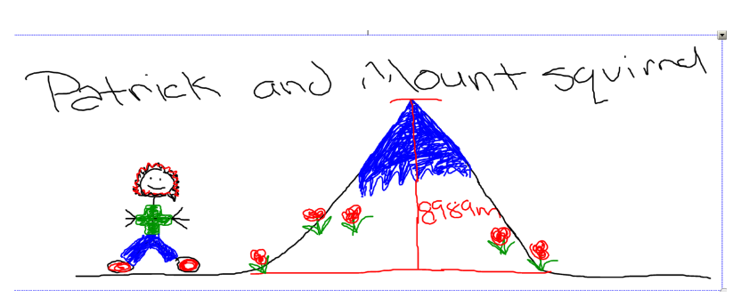

Illustrations drawn by Miranda and Amanda

1. If the force of gravity between 2 planets is 20000N what would the gravitational force be if one planet was doubled in size, the other shrinks to 1/8th it’s original mass and they move to twice the distance that they were.
2. What is the force of gravity between planet Robbie (mass= 7.35x10^22 kg) and planet Katy Perry (mass=8.88x10^21kg) if they were 1.88x10^8m apart?
3. Give and explain 3 factors that affect the tides on earth
4. Explain gravitational assist and give an example of where we use it.

4.3

1. A 55-kg astronaut (named Patrick) in a spacesuit is standing on a scale in a rocket The acceleration of the rocket is 22.6 m/s2 [up]. Calculate his true weight and apparent weight during liftoff on Earth. The acceleration due to gravity on Earth’s surface is 9.81 m/s2 [down].
2. A person orbiting Earth in a spacecraft has an apparent weight of zero. Explain if the person still experiences a gravitational force.
3. What is true weightlessness and where would it occur?