**10C – RF6 V1 Relations & Functions – Forms of Equations**

**Part I:**

1. Graph each linear relation. State the slope and *y­*-intercept of each.
   1. 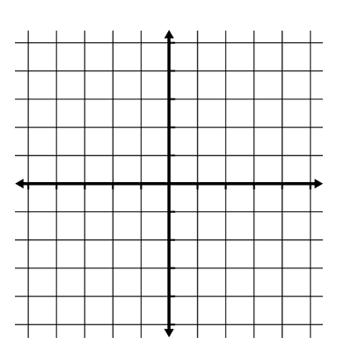
   2. 
   3. 
   4. 

**Part II:**

1. Rewrite the equation $y=-\frac{2}{3}x-3$ in
   1. General Form
   2. Slope-Point Form



1. Match each equation below to its graph.

$y-6=-4(x+1)$

$x-4y-8=0$

$4x-y-2=0$

$y=-\frac{1}{4}x+2$

**Part III:**

1. Determine if the equations $3x+2y+9=0$ and $-2x-3y-4=0$ form either parallel or perpendicular lines. Justify your solution.