10C – RF6 V2 Relations & Functions – Forms of Equations

Part I:
- Graph each linear relation. State the slope and y-intercept of each.

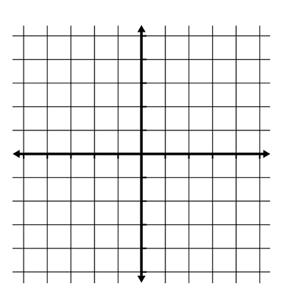
  - $y=\frac{1}{2}x+5$

  - $-3x+5y-15=0$
  - $y-5=2(x-3)$

  - $2x-6=0$

Part II:
- Rewrite the equation $2x+3y-18=0$ in

  - Slope-Intercept Form
  - Slope-Point Form

- An iron horse pump jack starts to pump crude oil into a tank at a constant rate of 1.5 m³/h. After 24 hours, the tank contains 32 cubic meters of oil.
  - Write an equation that describes the volume, V, of oil in the tank after, t, hours.

  - If this type of tank holds a maximum of 170 cubic meters of oil, then how long will it take to fill the tank?

  - Was the tank empty before it started filling? Explain.

Part III:
- Rewrite the equation $y=2\left(x^{2}-3\right)+5$ in general form.

