**10C – RF1 V2 Relations & Functions – Graphs**

**Part I:**

1. State the domain and range for the following:
   1. Graphs

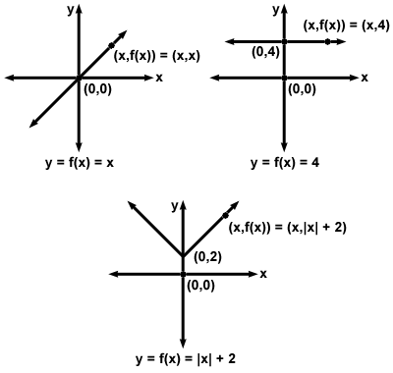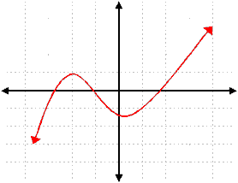

* 1. Table of Values

|  |  |
| --- | --- |
| ***x*** | ***y*** |
| -2 | -6 |
| -1 | -3 |
| 0 | 0 |
| 1 | 3 |
| 2 | 6 |

**Part II:**

1. Samuel went on a bicycle ride. He accelerated until he reached a speed of 20 km/h, then he cycled for 30 min at approximately 20 km/h. Samuel arrived at the bottom of a hill, and his speed decreased to approximately 5 km/h for 10 min as he cycled up the hill. He stopped at the top of the hill for 10 min.

Sketch a graph of speed as a function of time. Label each section of the graph, and explain what it represents.



1. For a graph of distance as a function of time, what does each segment represent?
   1. A horizontal line segment
   2. A segment that goes up to the right
   3. A segment that goes down to the right

**Part III:**

1. James can store 8 GB of music on his phone. If a 3-min digital song requires 3.5 MB of storage space, what are the domain and range for the relationship between memory used and number of songs that are each 3 min in length?