Unit 8: Waves
2 – Light
EM Radiation
- ________________ waves of energy

- The speed of light depends on the ______________
(denser __________)

- The speed of light in a vacuum is:

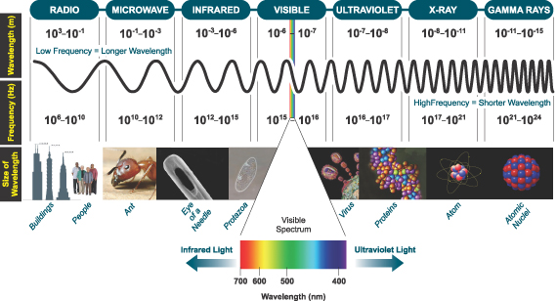

1) The Sun is 1.50x10⁸ km from Earth. How long does it take for the light from the Sun to reach us?

2) Alpha Centauri is the nearest solar system to ours, at 4.07x10¹³ km away. How long does it take for light to travel from Alpha Centauri to us?

- White light is actually a mixture of many different colours (_ _ _ _ _ _ _ _)
- Different colours of light have different _____________ and ______________.
Red has the ____________ λ
and violet the ___________ λ
- EM radiation is emitted from ______________ _________.
- After energy is absorbed by matter is emitted as EM radiation.
- Each element emits very specific frequencies (_______ ) of light known as _____________ _______________.

How We See …

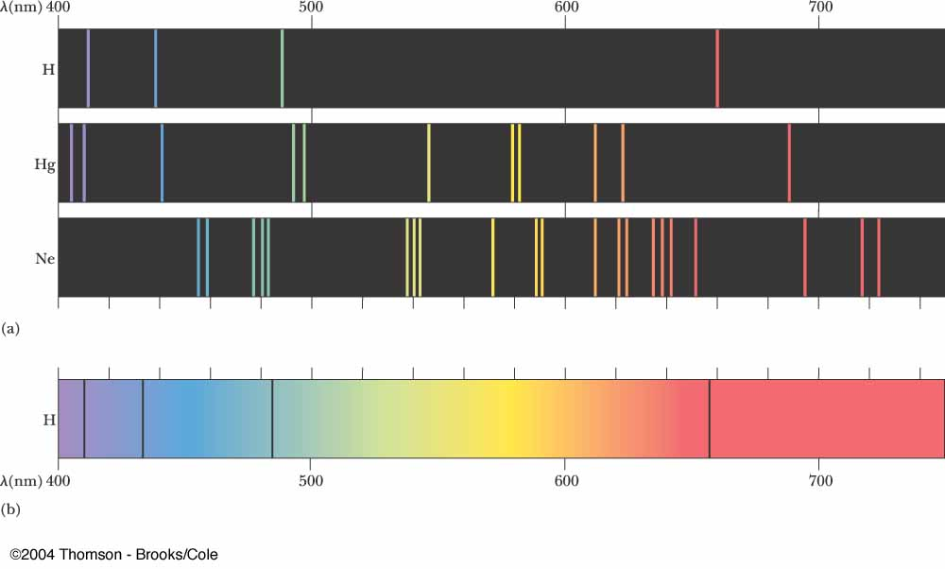

Speed of Light Lab
Purpose:

Procedure:

Calculations:

Discussion:
1) What is a standing wave? Give an example.

2) A microwave oven generates microwaves at a specific frequency that cause water molecules to resonate. This in turn heats the food. What is resonance (you may have to do some research)? Give an example of resonance.

