Physics 11 Final Exam

True/False
Indicate whether the statement is true or false.

____ 1. The slope of a position-time graph of an object gives the speed of the object.

____ 2. The area under a velocity-time graph is the displacement of the object.

____ 3. The net force on an object is the resultant of the force vectors.

____ 4. The law of conservation of momentum states that the momentum of a closed, isolated system does not change.

____ 5. When there is an angle between the force and the displacement, W = F d cos θ.

____ 6. When a mass suspended from a spring is in its equilibrium position, the upward force exerted by the spring is equal to the downward force exerted by gravity acting on the mass.

____ 7. Sound waves will travel faster on a dry day than on a humid day of the same temperature.

____ 8. The virtual image as seen in a plane mirror is reversed both left-to-right and top-to-bottom.

____ 9. The focal point is the point through which parallel incident rays reflecting off the surface of a concave mirror converge.

____ 10. A light ray striking a convex mirror will reflect off at an angle greater than the angle of incidence.

Multiple Choice
Identify the choice that best completes the statement or answers the question.

____ 11. Which of the following is a pair of vector quantities?
a. | Speed — Distance | c. | Velocity — Displacement
b. | Velocity — Distance | d. | Speed — Displacement

____ 12. If a drag racer wins the final round of her race by going an average speed of 198.37 miles per hour in 4.537 seconds, what distance did he cover?
a. | 157,401 miles | c. | 0.2500 miles
b. | 2.500 miles | d. | 0.0121 miles

____ 13. Construct a position-time graph that shows the forward progress of Sunny The Dog in a straight line for 20 meters over the course of 4 seconds.
a. | 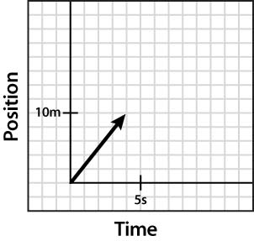 | c. | 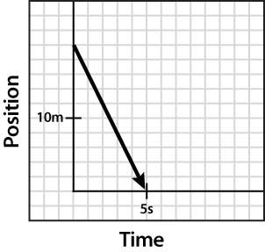
b. | 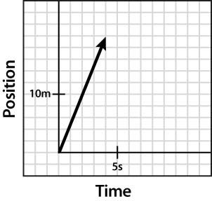 | d. | 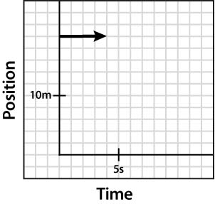

____ 14. Duplain St. is 300 m long and runs from west to east between Baron and Burkey. If Keith is strolling east from Baron at an average velocity of 3 km/hr, and Sue is power-walking west from Burkey at an average velocity of 6 km/hr, how long will it take them to meet?
a. | 1 minute | c. | 3 minutes
b. | 2 minutes | d. | 6 minutes

____ 15. The instantaneous acceleration of an object is
a. | the rate of change in velocity at an instant of time.
b. | the rate of change of position at an instant of time.
c. | the rate of change of speed at an instant of time.
d. | the rate of change of time at an instantaneous position.

____ 16. Which of the following is not true about a free body diagram?
a. | All forces point away from the particle.
b. | The arrows are proportional to the size of the forces.
c. | The system is represented by a particle model.
d. | You always know the magnitude of the forces ahead of time.

____ 17. When an object is in equilibrium, the net force is _____.
a. | zero | c. | negative
b. | positive | d. | changing

____ 18. Tension refers to
a. | the force exerted by a string. | c. | dynamic displacement.
b. | terminal velocity. | d. | free fall.

____ 19. The normal force (F_{N}) refers to
a. | the parallel contact force exerted by a surface on another object.
b. | the perpendicular contact force exerted by a surface on another object.
c. | the perpendicular tension exerted by a surface on a rope.
d. | the parallel acceleration of a body at terminal velocity.

____ 20. A wolf spider runs 75 cm west, then turns and runs 50 cm south. Which choice gives the correct solution for the resultant?
a. | R² = 75² + 50² | c. | R² = 75² 50²
b. | R² = 75² + 50² - 2(75)(50) cos 60 | d. | R² = 75² 50² - 2(75)(50) cos 90

____ 21. A 100.0 kg safe is pushed across a floor with a force of 450 N. The coefficient of kinetic friction is 0.35. What is the acceleration of the safe?
a. | 0.98 m/s² | c. | 5.0 m/s²
b. | 1.25 m/s² | d. | 12.5 m/s²

____ 22. An object that is shot through the air is called a
a. | protractor. | c. | parabola.
b. | projectile. | d. | proboscis.

____ 23. Karl is at a carnival. One of the midway games requires him to shoot at falling targets with an air rifle. Where should Karl aim?
a. | He should aim below the falling target.
b. | He should aim above the falling target.
c. | He should aim directly at the target.
d. | He should aim at the ground below the target.

____ 24. A strobe-light series of pictures is taken of a red ball and a blue ball. The red ball was allowed to drop straight down, and the blue ball was given an initial horizontal velocity. Lines are drawn connecting each red ball image with the corresponding blue ball image. Describe the lines connecting the images.
a. | The lines slope down from the red ball to the corresponding blue ball.
b. | The lines slope up from the red ball to the corresponding blue ball.
c. | The lines are vertical.
d. | The lines are horizontal.

____ 25. Gravity is what type of force?
a. | field force | c. | normal force
b. | contact force | d. | frictional force

____ 26. Analyze the graph. Which quantity is equal to the impulse?
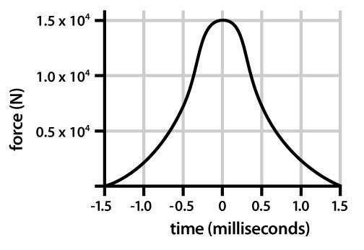
a. | time of collision | c. | slope of the curve
b. | distance along curve | d. | area under the curve

____ 27. Which type of energy is associated with a body’s height above the ground?
a. | thermal energy | c. | gravitational potential energy
b. | elastic potential energy | d. | rest energy

____ 28. 50 g of ice at 0°C is dropped in a beaker containing 100 g of water at 0°C. What will be the contents of the beaker after 5 hours? Assume that the room temperature is 0°C.
a. | 150 g of water | c. | 75 g of ice and 75 g of water
b. | 25 g of ice and 125 g of water | d. | 50 g of ice and 100 g of water

____ 29. Which is an example of heating through conduction?
a. | a ceiling fan pushes warm air downwards in winter
b. | touching a hot stove
c. | using a greenhouse to grow plants in winter
d. | The sun heats up the inside of a car

____ 30. Which is the transfer of thermal energy through the motion of particles caused by temperature differences?
a. | conduction | c. | convection
b. | radiation | d. | specific heat

____ 31. A 2.15 kg block of aluminum (specific heat = 897 J/kg·K) is at an initial temperature of 300 K. What will its final temperature be if 335,000 J of thermal energy are added?
a. | 474 K | c. | 803 K
b. | 174 K | d. | 447 K

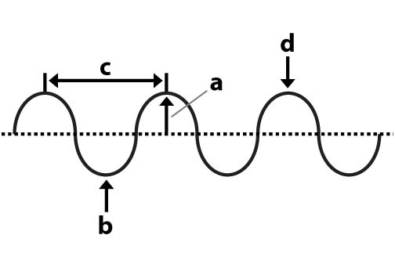

____ 32. In the diagram, the amplitude of the wave is shown by:

a. | c | c. | b
b. | d | d. | a

____ 33. In the diagram, the crest of the wave is shown by:

a. | c | c. | b
b. | d | d. | a

____ 34. What is the spring constant for a spring that stretches by 27 cm when a load of 200 N is suspended from it?
a. | 0.135 N/m | c. | 740 N/m
b. | 54 N/m | d. | 7.4 N/m

____ 35. If 320 J of work is done on a spring with a spring constant of 730 N/m, how far will it stretch?
a. | 0.58 m | c. | 0.61 m
b. | 0.87 m | d. | 0.94 m

____ 36. A bell with a fundamental frequency of 880 Hz is moving toward an observer at 3.5 m/s. If the speed of sound is 343 m/s, what pitch would be heard by the observer?
a. | 871 Hz | c. | 880 Hz
b. | 889 Hz | d. | 884 Hz

____ 37. Which of the following ray diagrams is correct?

a. | 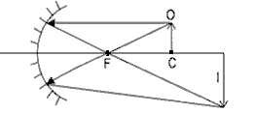 | c. | 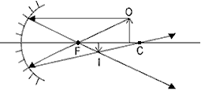
b. | 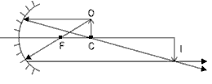 | d. | 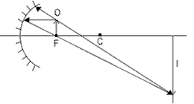

____ 38. Which type of image is produced by a convex mirror?
a. | enlarged and real | c. | enlarged and virtual
b. | reduced and virtual | d. | reduced and real

____ 39. A concave mirror produces a smaller, inverted, real image. Which is true regarding the image distance?
a. | It is between the radius of curvature and the focal point.
b. | It is closer to the mirror than the focal point.
c. | It is at the focal point.
d. | It is farther away than the radius of curvature.

Physics 11 Final Exam
Answer Section

TRUE/FALSE

1. ANS: F
The slope of the position-time graph of an object indicates the average velocity of the object.

PTS: 1 DIF: Bloom’s Level 1 REF: Page 44
OBJ: 2.4.2 Differentiate between speed and velocity. NAT: B.4
TOP: Differentiate between speed and velocity. KEY: Average velocity, Average speed
MSC: 1
NOT: /T/ The slope of a position-time graph of an object gives the average velocity of the object. /F/ Correct!

2. ANS: T
The displacement of an object is equal to the area under the velocity-time graph of that object.

PTS: 1 DIF: Bloom's Level 2 REF: pp. 66-67
NAT: B.4

3. ANS: T
The resultant of the force vectors on an object is called the net force.

PTS: 1 DIF: Bloom’s Level 3 REF: p. 92
NAT: B.4

4. ANS: T
This law applies only to closed, isolated systems.

PTS: 1 DIF: Bloom's Level 1 REF: p. 237
NAT: B.4

5. ANS: T
As the angle approaches zero, cosine of the angle approaches 1.

PTS: 1 DIF: Bloom's Level 1 REF: pp. 259-260
NAT: B.5 | B.6

6. ANS: T
When a mass is not accelerating, all of the forces on that mass cancel.

PTS: 1 DIF: Bloom's Level 2 REF: p. 376
NAT: B.6

7. ANS: F
Sound waves will travel slower on a dry day than on a humid day of the same temperature.

PTS: 1 DIF: Bloom's Level 3 REF: pp. 404-405
NAT: B.6

8. ANS: F
The virtual image as seen in a plane mirror has a front-to-back reversal from the object.

PTS: 1 DIF: Bloom's Level 2 REF: p. 463
NAT: B.6

9. ANS: T
Incident rays parallel to the principle axis reflect off a concave mirror and converge at the focal point.

PTS: 1 DIF: Bloom's Level 2 REF: p. 464
NAT: B.6

10. ANS: F
A light ray striking any mirror will reflect off at an angle equal to the angle of incidence.

PTS: 1 DIF: Bloom's Level 2 REF: p. 458
NAT: B.6

MULTIPLE CHOICE

11. ANS: C
Velocity and displacement are vector quantities.

 | Feedback
A | Speed and distance are scalar quantities.
B | Velocity is a vector, but distance is scalar.
C | Correct!
D | Displacement is a vector, but speed is scalar.

PTS: 1 DIF: Bloom’s Level 1 REF: Page 35
OBJ: 2.2.3 Define displacement. NAT: B.4 TOP: Define displacement.
KEY: Vectors MSC: 1
NOT: /a/ Speed and distance are scalar quantities. /b/ Velocity is a vector, but distance is scalar. /c/ Correct! /d/ Displacement is a vector, but speed is scalar.

12. ANS: C
4.537 seconds/60sec per min = 0 .07562 min
0 .07562 min/60 min per hr = 0.001260 hr

(198.37 mph)(0.001260 hr) = 0.2500 miles

PTS: 1 DIF: Bloom's Level 3 REF: p. 44
NAT: B.4

13. ANS: B
A position-time diagram shows the distance traveled over a time interval. The slope of the line is the distance (20 m) divided by the time (4 s). Answer B shows a line with the slope of 20/4 = 5m/s, in the positive direction.

PTS: 1 DIF: Bloom's Level 4 REF: p. 38
NAT: B.4

14. ANS: B
Sue is walking west at 6 km/hr = 6000m/60min = 100m/min.
Keith is walking east at 3 km/hr = 3000m/60 min = 50m/min.
By constructing a position-time graph for the two walkers, it can be seen that they will intersect after 2 minutes (Sue will have traveled 200 m, and Keith will have traveled 100 m.)
(Keith is dashed, Sue is solid.)
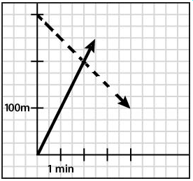

PTS: 1 DIF: Bloom's Level 3 REF: pp. 38-40, 43
NAT: B.4

15. ANS: A
Instantaneous acceleration is 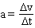 at an instant in time.

PTS: 1 DIF: Bloom's Level 1 REF: p. 59
NAT: B.4

16. ANS: D
You do not always know the magnitude of the forces ahead of time for a free-body diagram.

PTS: 1 DIF: Bloom’s Level 2 REF: p. 89
NAT: B.4

17. ANS: A
The net force on an object in equilibrium is zero.

PTS: 1 DIF: Bloom’s Level 2 REF: p. 92
NAT: B.4

18. ANS: A
The force exerted by a string or rope is called tension.

PTS: 1 DIF: Bloom’s Level 1 REF: p. 105
NAT: B.6

19. ANS: B
The perpendicular contact force exerted by a surface on another object is called the normal force.

PTS: 1 DIF: Bloom’s Level 1 REF: p. 107
NAT: B.4

20. ANS: A
R² = 75² + 50²
Use the Pythagorean theorem to solve for the resultant.

PTS: 1 DIF: Bloom’s Level 3 REF: p. 120
NAT: B.4

21. ANS: A
Find the force of friction. First, find the normal force:
(mg) = F_{N}
(100.0 kg)(9.8 m/s²) = F_{N}
F_{N} = 980 N

The force of friction = μ_{k}F_{N} = μ_{k} mg = 0.35(980 N) = 343 N

Since there is an acceleration, there is an imbalance between the frictional force and the horizontal push:
F _{Net} = ma = F_{p} - F_{f}
ma = F_{p} - (μ_{k} mg)
a = [F_{p} - (μ_{k} mg)] / m
a = [450 N (343 N)] / 100 kg
a = 1.07 m/s²

PTS: 1 DIF: Bloom’s Level 5 REF: pp. 126-127
NAT: B.4

22. ANS: B
The only force on a projectile is the force of gravity.

PTS: 1 DIF: Bloom’s Level 1 REF: p. 147
NAT: B.4

23. ANS: C
The projectile from the gun will fall at the same rate as the target. This is one of the easiest shots to make.

PTS: 1 DIF: Bloom’s Level 3 REF: pp. 148-150
NAT: B.4

24. ANS: D
Horizontal motion is independent of vertical motion.

PTS: 1 DIF: Bloom’s Level 5 REF: pp. 148-149
NAT: B.4

25. ANS: A
Gravity is a field force.

PTS: 1 DIF: Bloom’s Level 2 REF: p. 182
NAT: B.4

26. ANS: D
When force is not constant, impulse is given by the area under the force v. time curve.

PTS: 1 DIF: Bloom's Level 4 REF: p. 230
NAT: B.4

27. ANS: C
Gravitational potential energy is defined in relation to a reference level where gravitational PE is zero.

PTS: 1 DIF: Bloom's Level 1 REF: pp. 288-289
NAT: B.5 | B.6

28. ANS: D

 | Feedback
A | For the ice to melt completely, there must be a source of energy.
B | For half the ice to melt, there must be a source of heat.
C | For some water to freeze into ice, it must lose heat to the other contents of the beaker.
D | Correct!

PTS: 1 DIF: Bloom's Level 1 REF: Page 324
OBJ: 12.2.1 Define heats of fusion and vaporization.
TOP: Define heats of fusion and vaporization. KEY: Change of state
MSC: 1
NOT: /a/ For the ice to melt completely, there must be a source of energy. /b/ For half the ice to melt, there must be a source of heat. /c/ For some water to freeze into ice, it must lose heat to the other contents of the beaker. /d/ Correct!

29. ANS: B
When you touch a hot stove, you rapidly heat your hand through conduction.

PTS: 1 DIF: Bloom's Level 3 REF: p. 317
NAT: B.6

30. ANS: C
Thermal energy transferred by the motion of particles is called convection.

PTS: 1 DIF: Bloom's Level 2 REF: p. 317
NAT: B.6

31. ANS: A
335,000 J = 2.15 kg · 897 J/kg·K · ()

PTS: 1 DIF: Bloom's Level 3 REF: p. 318
NAT: B.6

32. ANS: A
The amplitude of a wave is half the height of the wave from crest to trough.

PTS: 1 DIF: Bloom's Level 2 REF: pp. 382-383
NAT: B.6

33. ANS: D
The crest of a wave is the top of the wave.

PTS: 1 DIF: Bloom's Level 2 REF: p. 383
NAT: B.6

34. ANS: C
For the elastic force on a spring, F =
Here, 200 N/ 0.27 m = 740 N/m.

PTS: 1 DIF: Bloom's Level 3 REF: p. 376
NAT: UCP.3

35. ANS: D
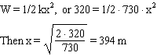

PTS: 1 DIF: Bloom's Level 3 REF: p. 376
NAT: UCP.3

36. ANS: B
The sound becomes higher in pitch as its source moves toward an observer.

PTS: 1 DIF: Bloom's Level 3 REF: pp. 407-408
NAT: UCP.3

37. ANS: D
Use the laws of reflection.

 | Feedback
A | A ray incident on the mirror passing through the focus must return parallel to its principal axis.
B | A ray incident on a mirror parallel to its principal axis does not reflect along the radius of curvature.
C | A ray pointing to the focus of a mirror does not reflect along the radius of curvature.
D | Correct!

PTS: 1 DIF: Bloom's Level 2 REF: Page 465
OBJ: 17.2.1 Explain how concave and convex mirrors form images.
TOP: Explain how concave and convex mirrors form images. KEY: Concave mirror
MSC: 2
NOT: /a/ A ray incident on the mirror passing through the focus must return parallel to its principal axis. /b/ A ray incident on a mirror parallel to its principal axis does not reflect along the radius of curvature. /c/ A ray pointing to the focus of a mirror does not reflect along the radius of curvature. /d/ Correct!

38. ANS: B
A convex mirror always produces a reduced and virtual image.

PTS: 1 DIF: Bloom's Level 3 REF: p. 473
NAT: B.6

39. ANS: A
When an object is placed between the radius of curvature and the focal point of a concave mirror, the resulting image is reduced and inverted.

PTS: 1 DIF: Bloom's Level 3 REF: p. 473
NAT: B.6

