**M10-C QUIZ Lin Eqs & Graphs / 13 Name: _____________**

C1-C2 Linear Relations & Graphing Lines

1. Determine the slope for each of the following. [1 mark each]



|  |  |
| --- | --- |
| **Time** | **Distance** |
| 1 | 5 |
| 2 | 10 |
| 3 | 15 |
| 4 | 20 |

a) b)

Slope = _________ Slope = _________

c) A line passing through the points (-4,0) and (5, -6).

Slope = _________

d) In September, Samantha’s hair was 20 cm long. After 4 months her hair was 26 cm long. What is the average rate of hair growth for Samantha, to the nearest tenth of a cm?

Ave. Rate of Growth = _________

2. Sketch a line with each of the given slopes. [1 mark]

a) Positive Slope b) Negative Slope c) Slope is 0 d) Slope is Undefined

3. Complete the table below. [2 marks]

|  |  |  |
| --- | --- | --- |
| **Equation:** | **Table of Values** | **Graph** |
| **Domain:** |
| **Range:** |
| **Linear or Non-Linear**  (Circle One) |
| **Slope:**  (If linear) |

4. The equation  defines a line.

a) Determine the *x*-intercept of the line. [1 mark] c) Graph the line. [1 mark]

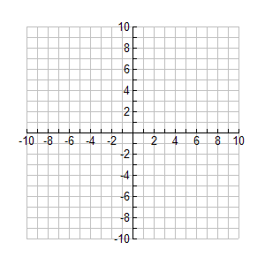

b) Determine the *y-*intercept of the line. [1 mark]

5. The equation defines a line.

a) Write the equation in slope-intercept form. [1 mark] c) Graph the line. [1 mark]

b) State the slope and *y*-intercept of the line. [1 mark]