**10C – RF4 V3 Relations & Functions – Representing Linear Relations**

**Part I:**

1. Which of the following relations are linear?
2. (3, -3), (0, -4), (-3, -5), (-6, -6)

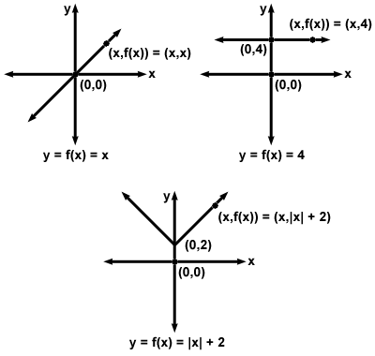

1. Every year on Sophie’s birthday, her grandmother gives her money. Each year Sophie’s grandmother gives her double what she gave her the year before.
2. For each, identify the independent and dependent variable.
   1. Jill earns $8 an hour working at a fast food resturaunt.
   2. 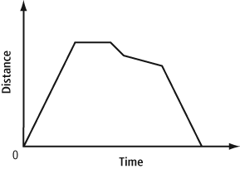

**Part II:**

1. ****A linear relation can be represented by the equation $y=-5x+100$
   1. Create either a table of values or list of ordered pairs that would represent the relation.
   2. Sketch a graph to represent the relation.
   3. Describe a scenario that would match the relation.

**Part III:**

1. Write an equation to represent the situation described below.

Every year on Sophie’s birthday her grandmother gives her money. Each year her grandmother gives her double what she gave her the year before. Sophie received $1 from her grandmother on the day she was born.