|  |  |  |
| --- | --- | --- |
| Stage 1 – Desired Results | | |
| **Established Goal(s):**  Math 10C – Relations and Functions **(RF3)**  **General Outcome**: Develop algebraic and graphical reasoning through the study of relations.  **Specific Outcome**: Demonstrate an understanding of slope with respect to: rise and run, line segments and lines, rate of change, parallel lines, and perpendicular lines. | | |
| **Big Idea(s):**   * Algebraic reasoning is a process of describing and analyzing generalized mathematical relationships and change using words and symbols. * Comparing mathematical relationships, for example, algebraically, numerically, verbally, or pictorially/concretely, helps us see that there are classes of relationships with common characteristics and helps us describe each member of the class. * Many equivalent representations can describe the same situation or generalization. Each representation may give a different insight into certain characteristics of the situation or generalization. * Limited information about a mathematical relationship sometimes, but not always, allows us to predict other information about that relationship. | | |
| **Enduring Understanding(s):**  *Students will understand that...*   * Slope represents the orientation of a line segment. * The value of slope can be determined in a variety of ways. * Slope represents a rate of change. * All line segments on a given line will have the same slope. * Lines that do not intersect have the same slope, and lines that intersect have different slopes. | **Essential Question(s):**   * What is the meaning of slope? * How do we describe slope? * How can slope help us to see lines with special properties (horizontal lines, vertical lines, parallel lines, perpendicular lines)? | |
| *Students will know...*   * Terminology   + Slope   + Rise   + Run   + Rate of Change   + Parallel   + Perpendicular   + Horizontal   + Vertical   + Line   + Line Segment | *Students will be able to...*   * I can determine the slope of a line given a graph. * I can determine the slope of a line given coordinates. * I can explain when the slope of a line is positive, negative, zero, or undefined. * I can draw a line, given its slope. * I can use slope to determine if two lines are parallel or perpendicular. * I can explain how slope is related to rate of change. | |
| Stage 2 – Assessment Evidence | | |
| **Mini Task(s):**   * Mini Task 1: Creating a Personal Logo | | **Other Evidence:**   * Formative Assessments * Check Ups * Strand Exam |
| Stage 3 – Learning Plan | | |
| **Learning Activities:**  **Activity 1: Describing and Measuring the Steepness of a Line**   * Copy and distribute the student handout in Appendix 1 to all students. Pair students up. * The graphs in appendix 1 are also available in the accompanying SMART notebook file.      * Ask students to examine the line segments in Graph 1. Ask them to answer the following two questions.   + Which of the lines is the steepest?   + How can you describe the steepness (of this line and the other lines) mathematically? * After allowing time for students to work, ask them to share their responses with the class. * Highlight the findings of any groups that may have used slope or a similar method. (Some students may be familiar with slope from science.) * Introduce the term **slope** to students. Help students to define this term and record the definition in their notebooks. Point out that the variable *m* is often used to represent slope on formula sheets.   + **Slope** – The ratio of the vertical change, or rise, to the horizontal change, or run, of a line or line segment. $m=\frac{rise}{run}$* Now that students are familiar with the term, ask students to determine/calculate the slope of the all the line segment pictures in graph I. * Ask students to describe how they could now use the slope to determine which line segment is the steepest. * Ask students to practice by determining the slope of the line pictured in Graph II. * Ask students what strategy they might use if they needed to determine the slope but were not given a graph.   + Determine the slope of a line segment with endpoints at (-3, 8) and (5, -10). * Ask students to share their strategies. Record the strategies in a list. Have students record this information in their notebooks.   + Some of the methods used may include:     - Counting out the rise and run using the graph.     - Measuring the base and height of a right triangle that has the line segment as its hypotenuse.     - Determining the change in the *y*-values and the change in the *x*-values of the coordinates.     - Using the slope formula to determine the rise and run. $m=\frac{y_{2}-y_{1}}{x_{2}-x_{1}}$* Have students determine the slope of lines that pass through the following sets of coordinates for practice. Encourage them to try more than one method.   + (-1, -4) and (3,7)   + (5, -4) and (-2, -8)   + (-2, 7) and (5, -6)   + (1, 9) and (-3, 7)   **Activity 2: Slope of Horizontal and Vertical Lines**   * Ask students to determine the slope of each line in Graph III from Appendix 1. * Ask students to describe what they noticed about each line and its slope. * Discuss why all horizontal lines will have a 0 slope and why this slope makes sense. * Repeat this process for the vertical lines in Graph IV, discussing why all vertical lines will have a slope that is undefined and why this makes sense. * Help students create a set of notes regarding the slopes of horizontal and vertical lines and record this information in their notebooks.   **Activity 3: Slope of Parallel and Perpendicular Lines**   * Have students determine/calculate the slope of each line pictured in Graphs V and VI. * Ask students to identify any similarities or patterns they notice when comparing the slopes of the lines. * Help students summarize their findings by creating a set of notes detailing the relationship of the slopes of parallel and perpendicular lines. * Have students record this information in their notebooks.   **Activity 4: Putting it all Together**   * Have students summarize what they know about slope by answering the questions listed on the last page of appendix 1. * Discuss the answers to these questions as a class.   Debriefing Questions:   * What are two different ways to find the slope of a line? * If you determine/calculate a slope incorrectly, what are the mistakes that you likely made? * What do we now about the slopes of lines that are parallel? * What do we know about the slopes of lines that are perpendicular? * If the slope of a line is $\frac{-3}{2}$, what is the slope of a line that is parallel? Perpendicular? * What is the slope of line perpendicular to a horizontal line? * What is the slope of a line parallel to a vertical line?   **Formative Assessment Options:**   * + Bonnie Uses: Pages 152, 153 from *Algebra with Pizzazz* * McGraw Hill: Page 325-328 * Pearson: Pages 339-343   Pages 349-351   * Open Question / Exit Question   + Two lines are perpendicular to each other and intersect at the point (10, 5). What might the slopes of each of these lines be? Explain your thinking.   + Small, Marian & Lin, Amy (2010), *More Good Questions: Great Ways to Differentiate Secondary Mathematics Instruction*. New York, NY: Teachers College, Columbia University   **Problem Solving Activities**   * Use the provided performance task as a problem solving activity. | | |
| **Reflections:** (Things to change within this lesson plan before using it again.) | | |

**Performance Task(s)**

Task 1 – Creating a Personal Logo

Create a personal logo using the dot paper below. Your logo will be scored as follows:

To earn a maximum score of G, your logo must include:

* A line segment with a positive slope.
* A line segment with a negative slope.
* A line segment with a slope of 0.
* A line segment with an undefined slope.

To earn a maximum score of P, your logo must include all of the requirements above as well as:

* A pair of parallel line segments.
* A pair of perpendicular line segments.

To earn an E, your logo must include all the requirements above, as well as:

* None of the line segments used to fill the G requirements have slopes of 1 or -1.
* None of the line segments used to fill the P requirements have slopes that are 0, undefined, 1, or 1.

For each of the bulleted items above;

1. Identify the location of the line segment(s). You could do this by coloring the line a specific color, identifying its location using coordinates, naming each line, etc.
2. Calculate the slope of the line(s) to verify that it meets the requirement.



Appendix 1 Math 10C – RF3

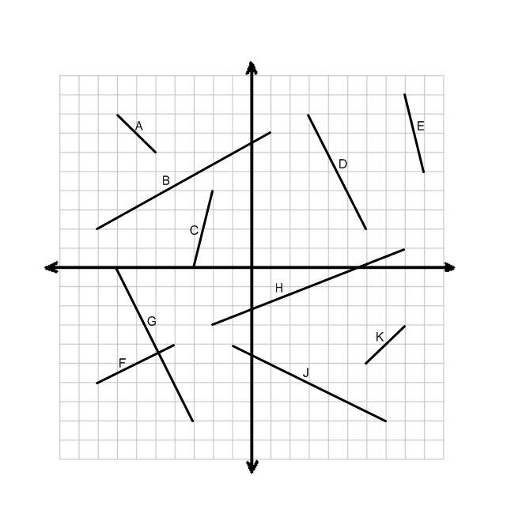**Graph I:**

Which of the lines is the steepest?

How can you mathematically compare the steepness of the lines?

**What is SLOPE? _______________________________________________________________________**

**_____________________________________________________________________________________**

**_____________________________________________________________________________________**

**Graph II:**

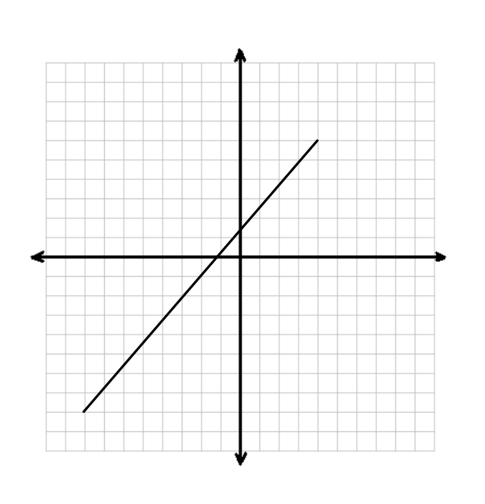

SLOPE CALCULATIONS:

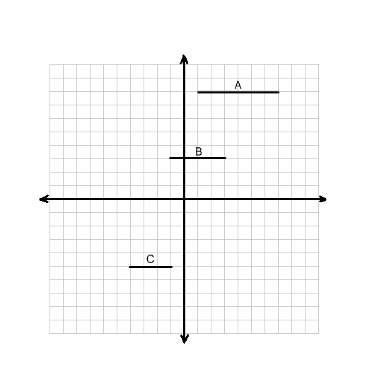Slopes of Horizontal and Vertical Lines

**Graph III:**  Calculate and compare the slope of each line.

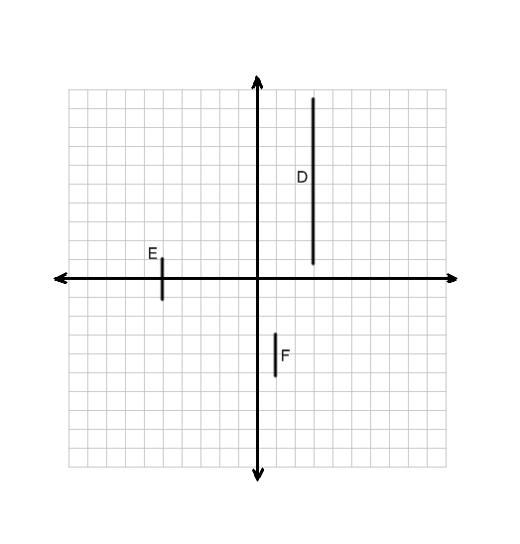

**Graph IV:** Calculate and compare the slope of each line.

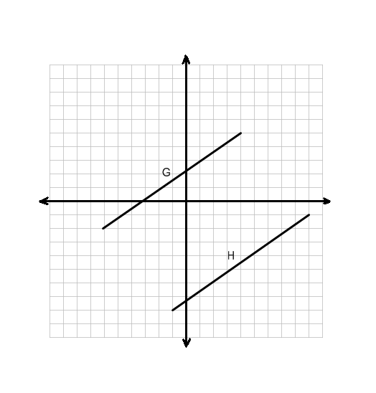Slopes of Parallel and Perpendicular Lines

**Graph V:** Calculate and compare the slope of each line.

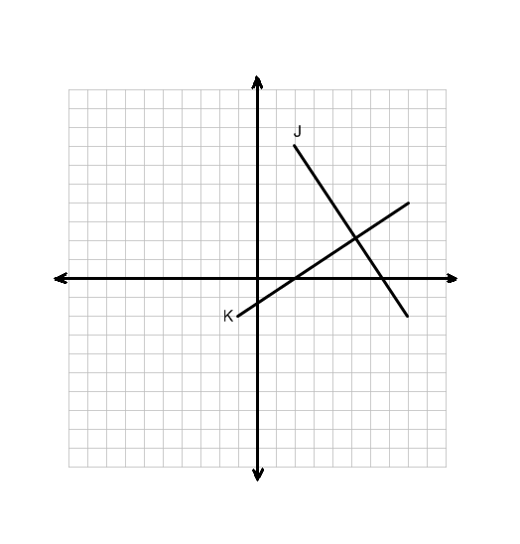

**Graph VI:** Calculate and compare the slope of each line.

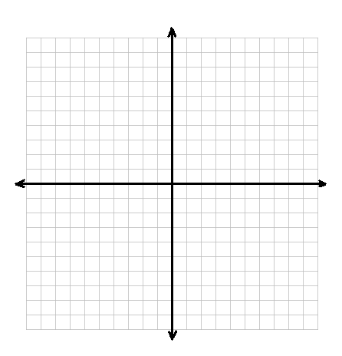Check Your Skills

1. Draw a line with a positive slope that is very steep. Label this line L.
2. Draw a line with a negative slope that is NOT very steep. Label this line M.
3. Show your partner and defend your drawing mathematically.



1. Draw a line with a slope that is 0. Label this line P.
2. Draw a line with a slope that is undefined. Label this line Q.
3. Show your partner and defend your drawing mathematically.



1. Draw a line segment and label it R. Determine its slope.
2. Draw a line segment that is parallel to R and label it S.
3. Draw a line segment that is perpendicular to R and label it T.
4. Show your partner and defend your drawing mathematically.

SLOPE NOTES

1. What is slope?
2. How can you determine the slope of a line or line segment?
3. Can you use slope to determine the location of a line or line segment on a coordinate plane?
4. How can you tell if a line will be very steep or not from the slope?
5. What does a positive or negative value for slope tell you about the line?
6. What unique slopes do horizontal and vertical lines have?
7. What relationship do the slopes of parallel lines have? Perpendicular lines?