**10C – RF5 V1 Relations & Functions – Graphs of Linear Relations**

**Part I:**

1. 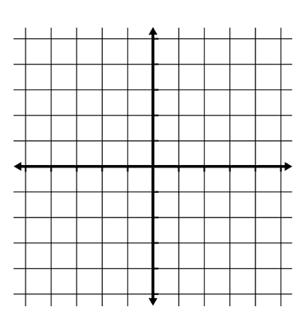Determine the following characteristics of the linear relation.
   1. *x*-intercept
   2. *y*-intercept
   3. slope
   4. domain
   5. range

|  |  |
| --- | --- |
| ***Long Distance Minutes*** | ***Total Cost*** |
| 0 |  |
| 20 |  |
| 40 |  |
| 60 |  |
| 80 |  |

**Part II:**

1. A cell phone company charges $45/month, plus $0.25/minute for long distance calls.
   1. Complete the table of values and sketch a graph to represent the relation.
   2. Determine the *y-*intercept. What does this value represent in terms of the scenario?
   3. Determine the slope. What does this value represent in terms of the scenario?
   4. State the domain and range.

**Part III:**

1. Complete the following:
   1. Write an equation to represent the scenario described in question 2.
   2. Determine the *x*-intercept and explain why it is not part of the domain.