Pre-Christmas Waves/Optics Make Sure Your Getting This Stuff Quiz:

Psalm 23:4 Version 2

1. A ray of light is reflected in a mirror as shown. What is the angle of reflection in the second mirror?

50˚

120˚

r˚

a) 30˚

b) 40˚

c) 50˚

d) 60˚

2. Which of the following best describes the image formed by a concave mirror when the object is located somewhere outside the focal point (F)?

|  |  |
| --- | --- |
| a. virtual, upright and enlarged | b. real, inverted and reduced |
| c. virtual, upright and reduced | d. real, inverted and enlarged |

3. A real image forms 15.0 cm in front of a concave mirror, which has a focal length of 10.0 cm. How far is the object from the mirror?

4. Where will the image show up of any convex mirror?

5. What is the focal length of a concave mirror that forms an image on a screen 10.0 cm away, of an object that is 15.0 cm in front of the mirror?

6. Assuming the diagram below is drawn as you’ve known them(concave mirror), IE the top ray is parallel to the principle axis and they meet up where they’re supposed to…show me the ray diagram where the image will be, and approximately how big it will be.

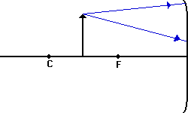

7. Construct ray diagrams to show where the images of the following objects are located (it’s a convex mirror. Draw in the complete image (approximated by an arrow) and describe its characteristics (real or virtual, enlarged or reduced in size, inverted or upright).

|  |
| --- |
| http://gbschemphys.com/chemphys/reviews/u2review/q38a.gif |

8. What is the amplitude of the wave in diagram 5-21?

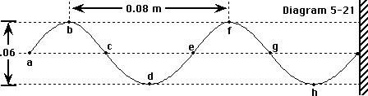

|  |  |  |  |
| --- | --- | --- | --- |
| a. 0.03 m. | b. 0.04 m. | c. 0.05 m. | d. 0.06 m. |

9. How many complete waves are shown in diagram 5-39?

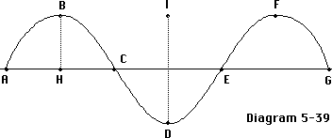

|  |  |  |  |
| --- | --- | --- | --- |
| a. 1 | b. 2 | c. 3 | d. 1.5 |

10. a. Which two waves have the same wavelength?

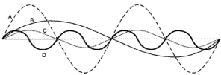(1) A&B

(2) A&C

(3) B&D

(4) C&D

11. You are approaching a stationary whistle (fo = 2.15 x 103 Hz) at a speed of 20 m/s. If the speed of sound is 339 m/s, what is the apparent frequency that you hear?

(2.31 x 103 Hz)

12. You are moving away from the whistle in problem #11 at a speed of 35 m/s. If the speed of sound is still 339 m/s, what is the apparent frequency that you hear?