Is Wendy Right?

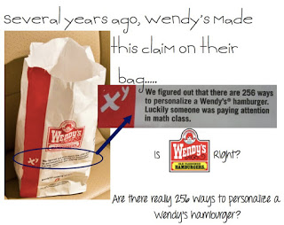

Wendy’s topics as of this bag being printed were:
The toppings one can select from are:
1) American Cheese
2) Mayonnaise
3) Ketchup
4) Crinkle Cut Pickles
5) Red Onion
6) Tomato
7) Lettuce
8) Applewood Smoked Bacon
9) Mustard

What would other toppings be that you’d like?
1)
2)
3)
4)

Are there really 256 ways to personalize a Wendy’s hamburger?

- Is that number to low or too high? Why?

- How many different ways do you think there is to personalize a Wendy’s hamburger? Show me mathematically.

- List out the different toppings to put on your hamburger at Wendy’s:

- To calculate, we will use either permutation or combination. Which one should we use? Why?

- What is the formula for combination?

- What is the formula for permutation?

- Calculate what it should have been, and based on the below photo calculate what it is now! (you can also include bacon, or other toppings you put on)

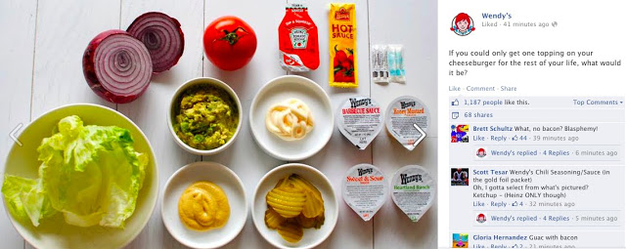

There are _______ ways to personalize a Wendy’s hamburger!

- The number of ways to personalize that you found is for a single patty burger. How could we find the number of ways to personalize for a single, double, or triple stack?

- Calculate the number of ways to personalize a Wendy’s single, double, and triple stack.

10. When we go on our field trip to Wendys what are you going to order, is there a few ways you can order it?

