Work & Power & Efficiency Quiz Version 2

- Johnny Racecar loves going fast in his go-kart. How fast would Johnny be rocking if he took his go-kart to the top of Knox mountain (neglecting air and friction) that stands 235m? (3)

- Johnny was a smart man, show if he finished pushing his go-kart up the hill (mass of 40kg) at 2 m/s, how much work was done to get it up there?(4)

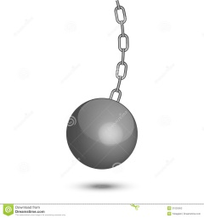
- A wrecking ball is a machine that smashes into building to knock them over. If the mass of the ball is 700kg and strikes the building going 12m/s at 4m above the ground, and the ground resistance is 1.4x10⁴N how far does the building move?(3)

- A 1000kg car has an efficiency of 74%. If the car has a motor that is capable of 300,000W, will the car be able to make the power output needed to accelerate the car from rest to 26m/s over 12m?(5)

- In my spare time I like to push boulders around, like a mole does underground. How much power do I need to push a 18kg block at 3m/s for 10 seconds.(2)

