Most Angry Birds are projectiles.

A projectile is an object that:

* Is travelling through the air.
* Has only one force acting on it (Force due to gravity).
* Has no thrust or driving force.

Q: Which of these Angry Birds breaks the rules of a projectile.

**Projectiles**

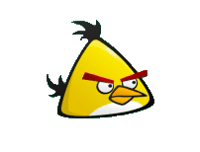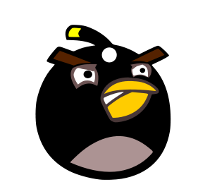

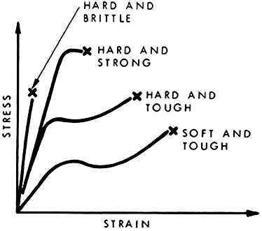C:\Users\Paul Thompson\Desktop\Angry birds\Blocks.jpg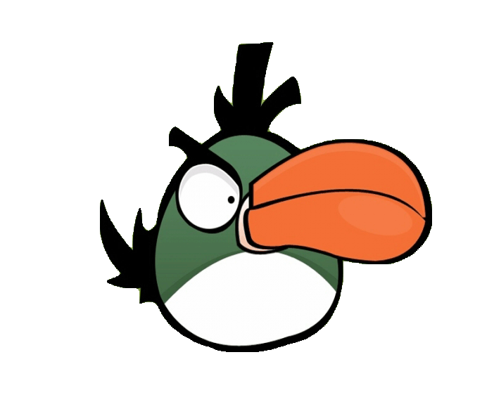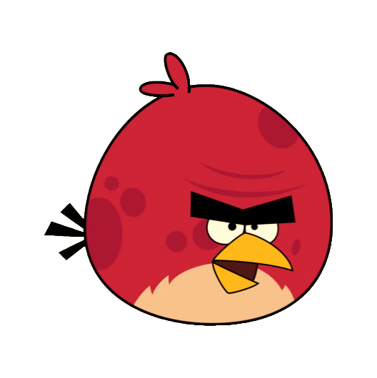

**A**

**B**

**C**

**Strain**

**Stress**

The materials in Angry Birds have different breaking strengths.

* Stress = the force that an area of the material is experiencing.
* Strain = the extension of the material because of the force.

All Angry Birds materials are very brittle as they do not stretch, although they take different amounts of stress before breaking.

Q: Which line on this graph is for Angry Bird wood?

**Breaking Stress.**

Turning Force

Boomerang Angry Birds require a turning force to change direction.

If the Boomerang Angry Bird can only produce a set amount of turning force then the faster it goes the longer it will take to turn.

1. Low speed turn. 2. High speed turn.

Q: What would happen to the turn radius (r) if the mass (m) of the Angry Bird was higher?

**Changing direction.**

**r = mv2/F**

**v2 = u2 + ½at**

**s = ½(v + u)t**

**s = ut + ½at2**

**v = u + at**

**v = d/t**

If the speed of an object is constant only one equation is needed.

This is used in Angry Birds for the horizontal speed of a bird.

If the speed is changing because of a constant force being applied (ie: force due to gravity) then special kinematic equations need to be used.

Q: which part of an Angry Birds motion uses these formulas?

**Moving Maths.**

**p = mv**

Momentum is an objects ability to keep in motion. The more momentum an object has the more force it will take to stop it.

Momentum (p) has two factors that make it bigger; Mass (m) and Speed (v).

In the world of Angry Birds the more momentum a bird has the more structures it will break before it is stopped.

Q: Which Angry Bird will have the least momentum? Why?

**Momentum.**

In order for anything in the universe to happen, energy is needed.

In the world of Angry Birds energy is provided by the slingshot in the form of ‘elastic potential energy’.

The elastic potential energy (EE) is very rapidly converted into kinetic (movement) energy (EK) when the slingshot is released.

The further back (x) the slingshot is pulled the more energy (EE) and speed the projectile will have (v).

Q: What kind of energy does the kinetic become when the Angry Bird is at its highest point?

**Energy.**

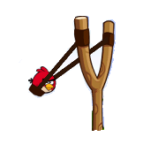i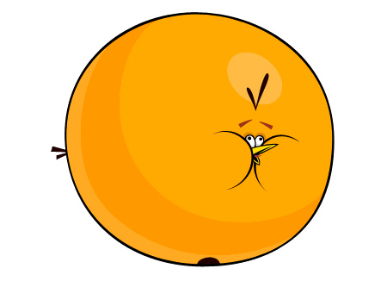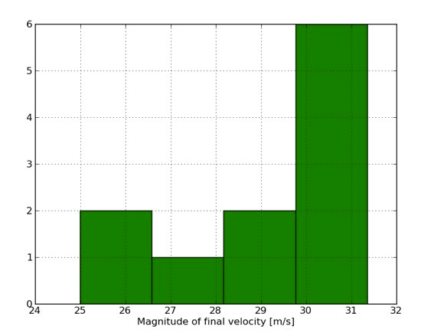<http://www.wired.com/images_blogs/wiredscience/2011/11/accel_tap.jpg>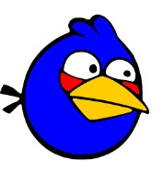

**v = √kx2/m**

**EE = EK**

**Ek = ½mv2**

**EE = ½kx2**

**vj = v sin θ**

**vi = v cos θ**

Launch angle changes the distance that an Angry Bird will fly.

If a high launch angle is used then more of the launch speed goes into the vertical speed and sends the Angry Bird higher, but it won’t travel as far.

If the launch angle is low then more of the launch speed will go to horizontal speed, but the Angry Bird will not go as high and so cannot travel a great distance.

The perfect angle for distance is between the two.

Q: What angle do you think will give the longest distance flight?

**Launch Angle.**

A projectile with only the force of gravity acting on it will follow a parabolic path.

The parabolic path is caused because the horizontal speed stays constant, as there is no force acting on it.

When air resistance is present the horizontal speed is affected and the path is shortened, it is no longer an even parabola.

Q: Does the world of Angry Birds have any air resistance? (Look at the shape of the path of the Angry Bird).

**Air resistance.**

The new orange bird puffs up enough force to knock over the pigs structures.

To expand the pressure inside the orange bird must be greater than atmospheric pressure .

The Ideal gas law states:

PV = nRT

n = number of moles

R = Universal gas constant

T = Temperature

V = Volume

P = Pressure

If the Temperature and amount of moles are constant then the as the volume increases the pressure drops. The final pressure will need to be great than atmospheric pressure to counter the elastic nature of the birds skin.

Atmospheric pressure = 101.3 KPa, A reasonable estimate for the bird could be 110 KPa when inflated. The Radius is about 6 x larger when inflated.

V = 4/3 π r3

Q: What would the pressure be inside the orange bird before it expands?

A: 220 KPa 22000 KPa 0.55 KPa 110 KPa

**Blowing up.**

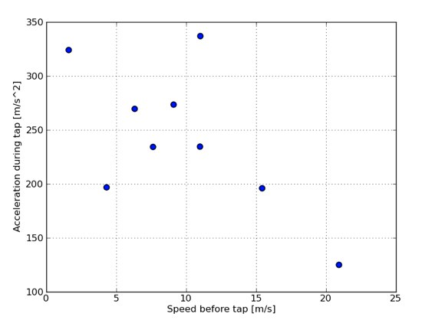

Graphs from: www.wired.com/wiredscience/2011/11/physics-of-the-yellow-angry-bird/

Speed

Time



The yellow bird speeds up when tapped, but is it the same acceleration each time?

What determines the acceleration?

Analysis has revealed that it is not constant and there is no link to the acceleration and the speed before the tap, but it does show that the acceleration varies a lot.

It appears that the yellow bird accelerates within a certain time frame to a constant final speed. So no matter what speed it was going before the tap it’s final speed ends up the same.

There is one other strange effect of the yellow bird is that at angles below the horizon it causes a change in gravity as its vertical acceleration changes dramatically.

Q: Is the force the yellow bird produces to accelerate constant? Explain.

Q: How could the physics of the yellow bird be changed to be more realistic?

Credit to [**Rhett Allain**](http://www.wired.com/wiredscience/author/rhettallain/) **on the wired science blog. Analysis was done using ‘Tracker video analysis’ http://www.cabrillo.edu/~dbrown/tracker/**

**Speeding up.**

The blue birds of Angry Birds split into 3 when tapped, but does this follow normal physics?

Is their momentum conserved?

The momentum before they split should equal their momentum after the split.

Momentum = speed x mass.

So as there is no evident change in speed the mass of the 3 birds after the split would need to be 1/3 of the original birds mass.

On analysis of collisions between a single blue bird (not split) versus the 3 split blue birds, it turns out they give about 30 times more momentum to objects they hit [1]. This means that each of the split birds is actually 10 times the mass of the original bird.

So the birds don’t conserve momentum, they generate 30 x more momentum with the increase in mass. So somehow they produce energy to increase mass and so create more momentum.

In short it is well worth splitting a blue bird before it hits.

So in this respect Angry Birds does not follow real world physics – But why should it?

Q: Could the blue bird work if real world physics applied to all aspects of the game? Explain.

1. http://www.wired.com/wiredscience/2010/10/does-the-angry-blue-bird-multiply-its-mass/

**Splitting up.**

C:\Users\Paul Thompson\Desktop\Angry birds\Beams.jpgC:\Users\Paul Thompson\Desktop\Angry birds\Beams.jpgC:\Users\Paul Thompson\Desktop\Angry birds\Blocks.jpgC:\Users\Paul Thompson\Desktop\Angry birds\Blocks.jpgC:\Users\Paul Thompson\Desktop\Angry birds\Beams.jpgC:\Users\Paul Thompson\Desktop\Angry birds\Beams.jpgC:\Users\Paul Thompson\Desktop\Angry birds\Beams.jpgC:\Users\Paul Thompson\Desktop\Angry birds\Beams.jpgC:\Users\Paul Thompson\Desktop\Angry birds\Beams.jpgC:\Users\Paul Thompson\Desktop\Angry birds\Beams.jpgC:\Users\Paul Thompson\Desktop\Angry birds\Blocks.jpgC:\Users\Paul Thompson\Desktop\Angry birds\Blocks.jpgC:\Users\Paul Thompson\Desktop\Angry birds\Blocks.jpgC:\Users\Paul Thompson\Desktop\Angry birds\Blocks.jpg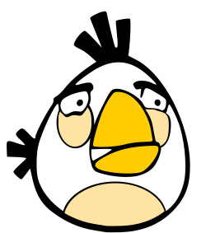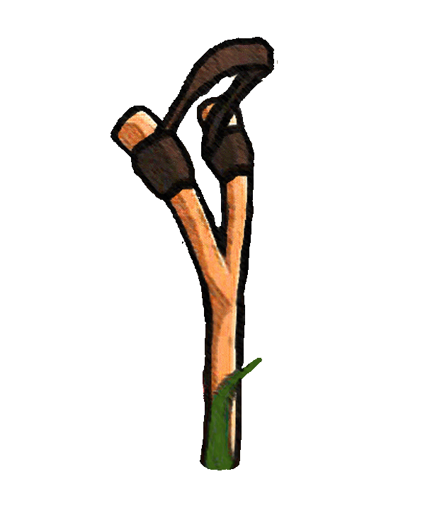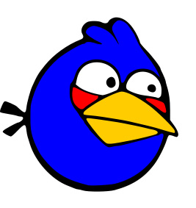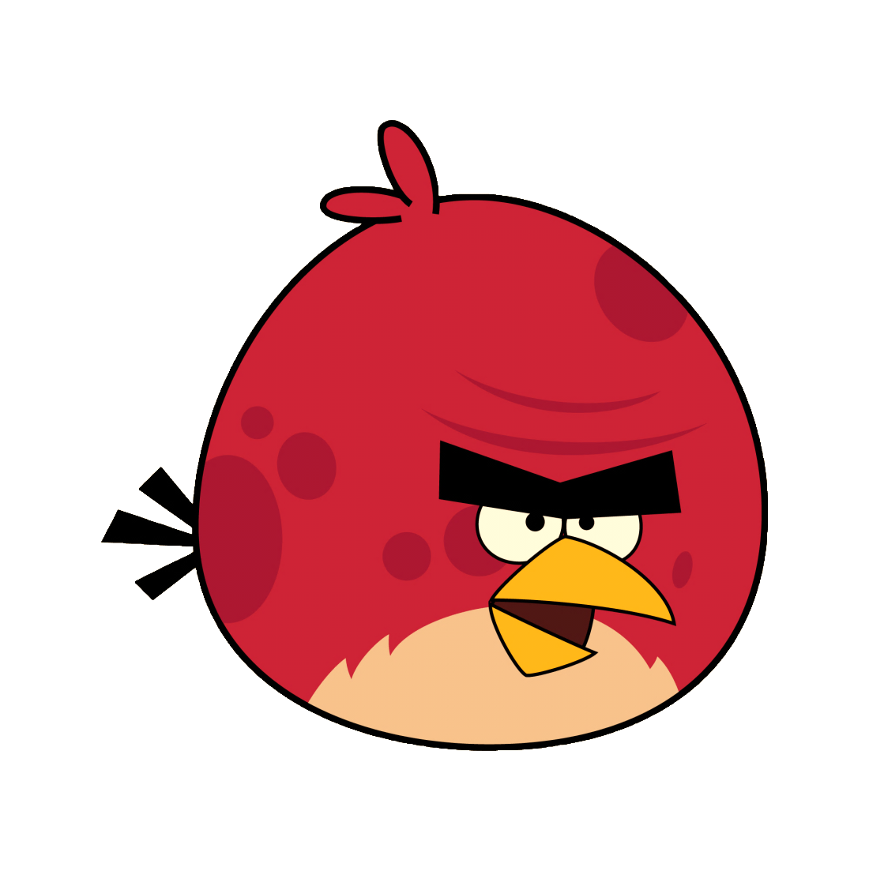

Force due to gravity.

The Physics

of