# http://images4.fanpop.com/image/photos/23100000/Transformers-movie-transformers-23140459-1152-864.png

# Autobots and Decepticons: Are You Ready To Rumble!!!!

So good news and bad news about all of this transformer business. First the good news! How awesome is transformer’s? Right I mean really! Bad news is the fantastic thing I put together from last year is now where to bed found due to the theft of my laptops last year. So I had to start from scratch and came up with this. It’s not as awesome but still it’s pretty cool.

Here’s how this is going to work. The booklet in your hand is the entire unit booklet. I’ll be taking this at various points to check on progress and we’ll be having quizzes etc throughout the unit but this way all your assignments are together. Not everything has to do with Transformers but the majority will. We will have one final project, in lieu, of an exam that will be the final battle between the Good and the Evil! Best of luck DECEPTICONS!

1. What is a right triangle?

2. In any triangle, what is the sum of the measures of the three angles?

3. Calculate the missing angle in the triangle below.

30°

4. State the Pythagorean Theorem, and explain when you would use it.

5. Those pesky Autobots have tracked down a map that will lead you to the AllSpark but you must solve using the Pythagorean Theorem to calculate the length of the unknown side in order to find it!

**a.**  **b.**  **c.**

7cm *c* *m* 15 cm 12 m 5m

*y*

4 cm 12 cm

L

**d.**  e.  **f.**

12.4 mm

15.42 in

14.9 km

w

p

24.1 in

11.5 mm

13.7 km

**6.** The Allspark measures 14 inches long and 18 inches high. What is the diagonal length of the Allspark?

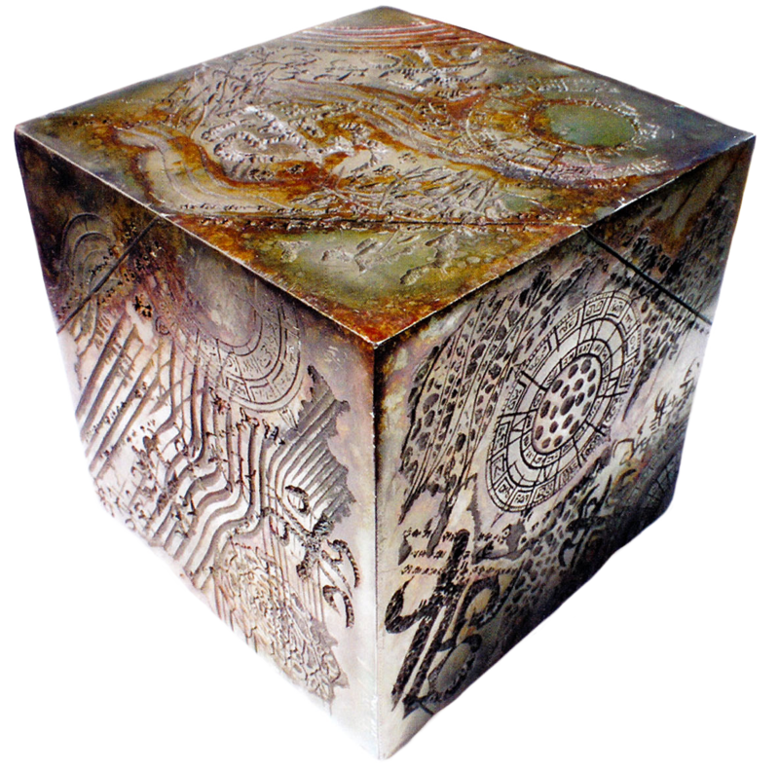

7. Megatron needed a rest, being a large robot, he leaned against 11m house. If the base of Megatron is 4m away from the house, how tall is the he? **Please draw a diagram and show all work**.

8. A TV antenna is 16 metres high. A supporting wire is connected to the top from 6 metres away from the base. This is shown in the diagram. Assuming this electricity would be used to stop the Autobots from chasing you how much wire would be needed to secure your trap?

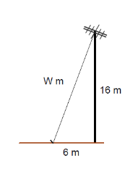

8m

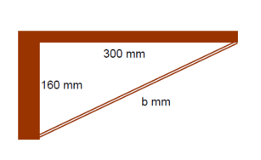

9. On Their way to get the map the Autobots come to a cantilever bridge. Solve for the length of the support marked ‘b’.

200mm

For each of the following triangles, determine each ratio then calculate each, accurate to four decimal places. (This is one of those I’m not sure how to Transformer this part up)

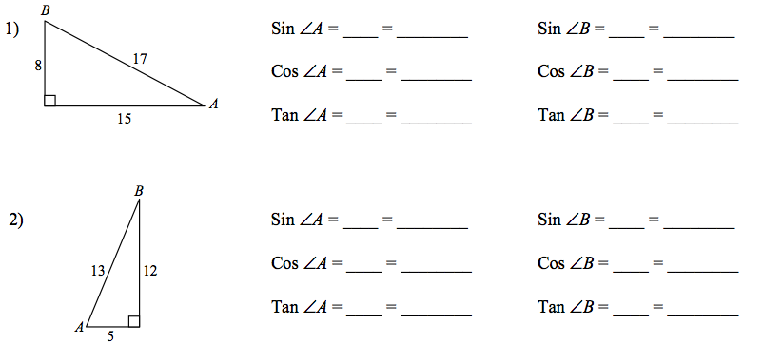

3. Find the measure of each side indicated. Round to the nearest tenth.

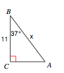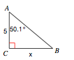

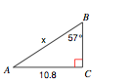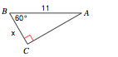

4. Find the indicated angles in each of the triangles below. Round your final answers to the nearest hundredth.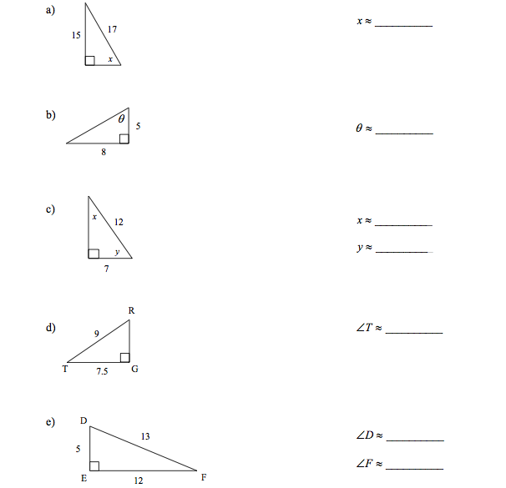

5. MathaTron had some problems with his homework at Transoschool. Can you find his mistakes and help him out?

|  |  |
| --- | --- |
| **Identify the Error** | **Correctly Solve** |
| Solve for the missing side labelled x. | Solve for the missing side labelled x. |
| Solve for the missing side x.        x = 37.74 | Solve for the missing side x. |

6. Find ALL the missing side and angle measures of the triangles below. Round your answers to the nearest hundredth.

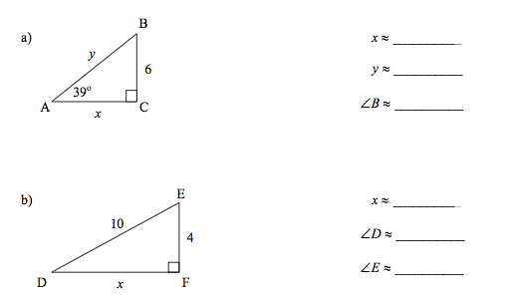

***Putting your knowledge to work.***

1. The blast from Bronx is 100-m long. If the blast makes an angle of 31° with the ground, find the height of Bronx.



2. Greaser is going to toss a car down the street. If he is 15.8m tall and the horizontal distance to his target, Caddytron is 33.4m, how far must he through the car?

3. StarScream is 250 m above the ground. An object is 205 m away from his line of site. What is the angle of depression of the person’s line of sight to the object on the ground rounded to the nearest degree?

4. In the first Transformers when there in the desert they run away from the scorpion Decepticon. If the pilot of the helicopter has taken off the ship and rose 500m with the angles given in the diagram below, how far away are the good guys?

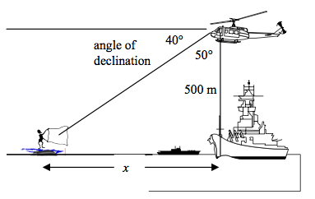

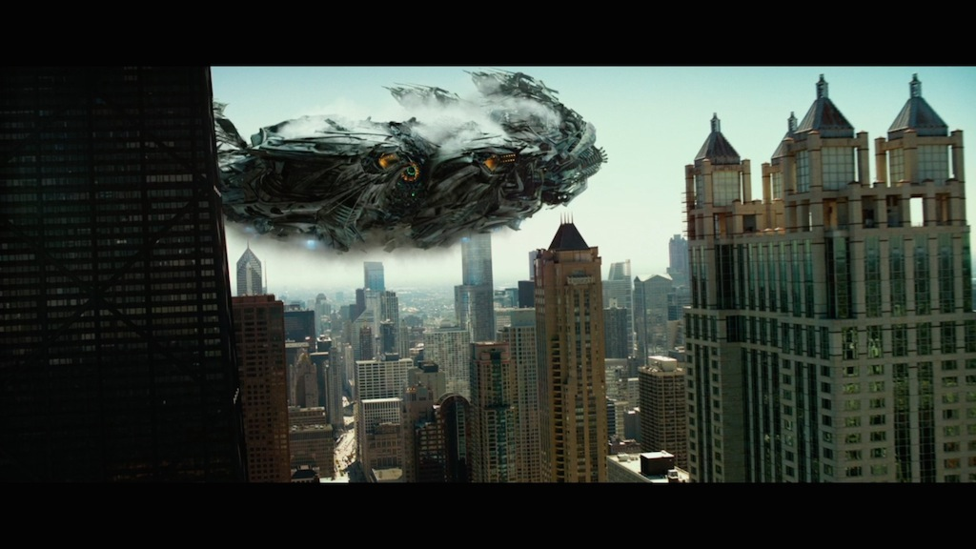5. From a height of 150 m in a tower, a Gavatron noticed the Autobots coming from a position due west of his location. The angle of depression was 10°. His friend Thundercracker was due east of him at an angle of depression of 5°. How far is either of them from the Gavatron?