10C – RF7 V1 Relations & Functions – Equations of Linear Relations

Part I:
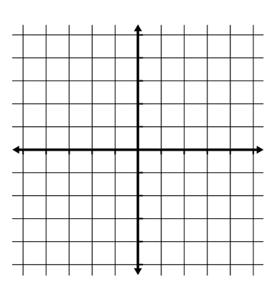
- Determine the equation of the line.

  - Has a slope of 0 and passes through the point (-3, 7).

Part II:
- Determine the equation of a line with an x-intercept of 4 and a y-intercept of -2.

- Determine the equation of a line that is parallel to $y=\frac{3}{4}x+4$ and passes through the point (0, -2).

- Determine the equation of a line that is perpendicular to $y=\frac{3}{4}x+4$ and passes through the point (-6, 6).

Part III:
- Determine the value of n if the linear relations form parallel lines when graphed.
$nx + 4y -2 = 0$ and $3x- 4y+7 = 0$

