10C – RF7 V3 Relations & Functions – Equations of Linear Relations

Part I:
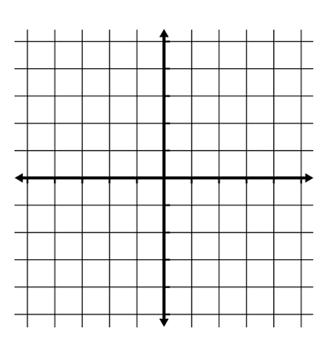
- Determine the equation of the line.

  - Has a slope of -3 and passes through the point (-5, -2).

Part II:
- Determine the equation of a line that passes through the points (2, 3) and (6, -5).

- A line passes through the point (-10, 5) and is parallel to $5x-2y+4=0$ Determine the equation of the line.

- A line passes through the point (-10, 5) and is perpendicular to $5x-2y+4=0$ Determine the equation of the line.

Part III:
- Triangle ABC has vertices at A (-2, 3), B (2, 1), and C (1,-4). Write the equation of the line containing the altitude from point B to side AC. (An altitude is a line segment drawn from a vertex perpendicular to the opposite side.)

