10C – RF6 V3 Relations & Functions – Forms of Equations

Part I:
- Graph each linear relation. State the slope and y-intercept of each.

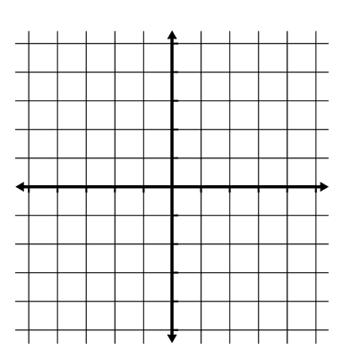
  - $y=-\frac{2}{3}x-3$

  - $4x-5y-40=0$
  - $y+2=-\frac{2}{3}(x+4)$

  - $y=0$

Part II:
- Rewrite the equation $y+2=-\frac{2}{3}(x+4)$ in

  - General Form
  - Slope-Intercept Form

- Which linear relations are equivalent to each other?
  - $y=3x+6$
  - $y-2=\frac{2}{3}(x-2)$
  - $y=\frac{2}{3}x-1$
  - $y-1=\frac{2}{3}(x-3)$
  - $2x-3y-3=0$
  - $3x-y-6=0$
  - $y-3=3(x-3)$
  - $y+3=3(x-1)$

Part III:
- Rewrite the equation ${(x+1)}^{2}+{(y-3)}^{2}=5$ in general form.

