Quadratic Functions Webquest Name ________________________

2 Date_____________

An Introduction to

Fill in this worksheet as you complete the webquest. Any work not finished in-class must be completed by the end of class. You may work with 1 partner, but you each must complete the packet in its entirety.

Before beginning your research…let’s fill in a K-W-L chart.

Write what you KNOW about Quadratic Functions and what you WANT to learn. We will fill in the LEARN section at the end of the unit. : ) Be thoughtful.

Topic: Quadratic Functions

KNOW

WANT

LEARN

Quadratic Function Webquest | 1

SECTION ONE: CHAPTER 5 VOCABULARY

Use an online math dictionary websites to define the following vocabulary terms.

- Quadratic Function:

- Parabola:

- Minimum Value:

- Maximum Value:

- Vertex

- Line of Symmetry

- Standard Form (Quadratic Function):

- Vertex Form (Quadratic Function):

Quadratic Function Webquest | 2

SECTION TWO: HISTORY OF THE PARABOLA

After reading through the websites, make a timeline for the evolution of the parabola below. Include important people and events. Expand as needed.

Quadratic Function Webquest | 3

SECTION THREE: PARABOLAS IN THE REAL WORLD

Browse the internet for uses of parabolas in the real world. Below, list 5 uses that you found interesting. Include a few sentences explaining each. Use pictures if necessary.

1.

2.

3.

4.

5.

Quadratic Function Webquest | 4

SECTION FOUR: EXPLORING QUADRATIC FUNCTIONS

Using the Desmos link, answer the following questions. Make sure you draw a graph that represents each scenario. Use different color pens/pencils to distinguish and write down each equation. This will be helpful later! Include three different examples for each question. Always begin with f(x) = x² + 1 (the website default). Draw this original in pencil.

1. When you move the a coefficient (the first one), describe what happens to the graph. Make sure you explore ALL possibilities. Only move the a value!!
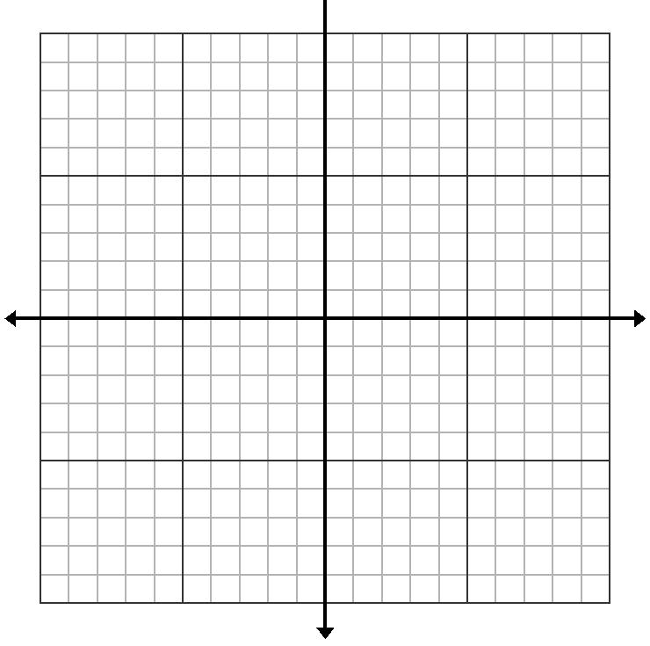

2. When you move the b coefficient (the second one), describe what happens to the graph. Make sure you explore ALL possibilities. Only move the b value – make sure your reset the graph after the first exploration before beginning!!
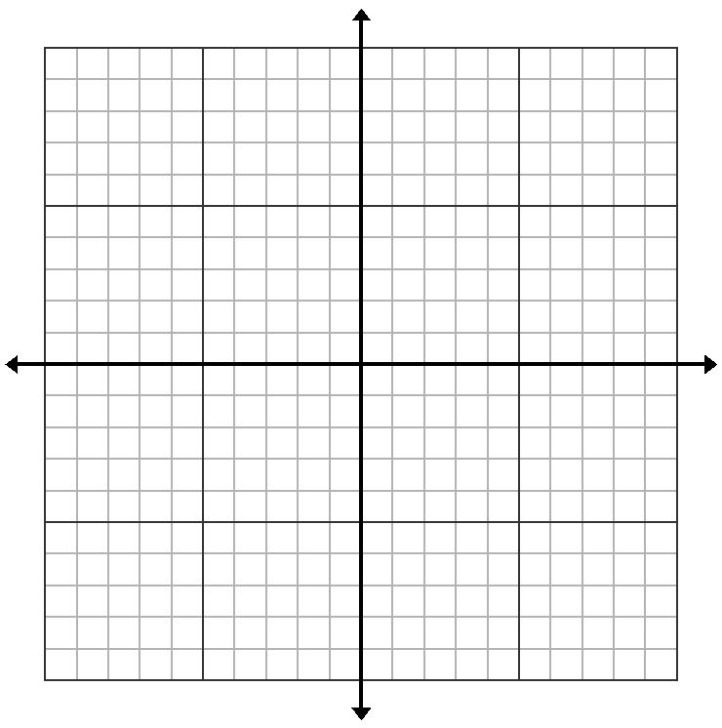

Quadratic Function Webquest | 5

3. When you move the c coefficient (the third one), describe what happens to the graph. Make sure you explore ALL possibilities. Only move the c value – make sure your reset the graph after the first exploration before beginning!!
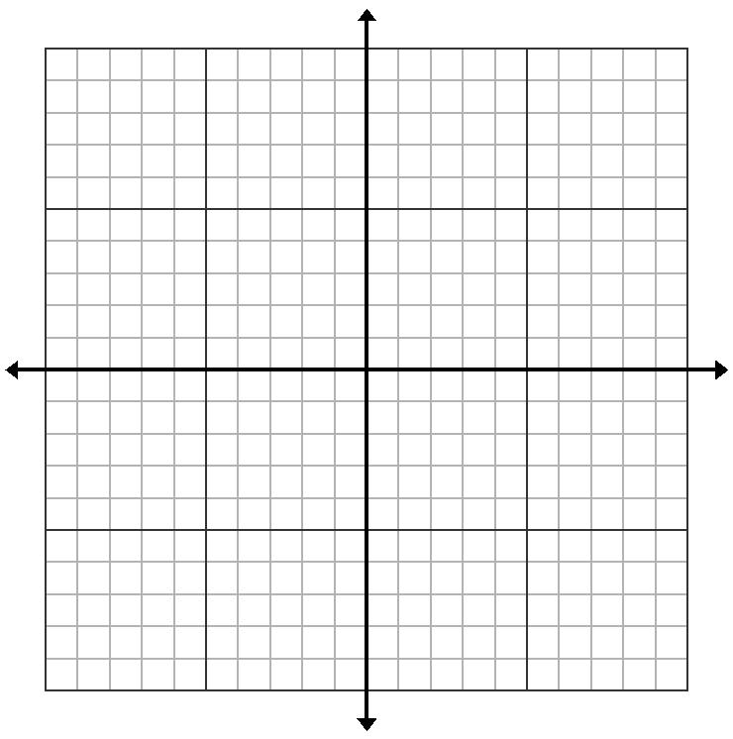

4. Write down a general statement about the effect of each variable on the graph.

Quadratic Function Webquest | 6

SECTION FIVE: QUADRATIC FUNCTIONS POWERPOINT

Watch the PowerPoint on mathcaddy.weebly.com, click precalc 11, quads and scroll down till you see it. Follow the directions on the PowerPoint – it is timed, so make sure you do not try to click ahead. You will have the click as you finish each slide. Answer the following questions that go along with the PowerPoint presentation.

- When will the parabola open up?

- When will the parabola open down?

- What is the standard form of a quadratic function?

- What is the equation for the line of symmetry?

- The line of symmetry always goes through the __________________.

- The line of symmetry gives us which coordinate for the vertex?

- How do we find the y coordinate?

- What are the three steps to graphing a parabola in standard form?

- Write down each step to graphing the last example.

CONGRATULATIONS! You have finished your Webquest on Quadratic Functions.

This is how your work will be evaluated.

 |  |  | Poor |  | Fair |  |  | Average |  |  | Exemplary |  | Score
 |  |  | 1 |  | 2 |  |  | 3 |  |  | 4
 |  |  | Insufficient |  | Below average |  |  | Average
 |  |  | amount of |  |  |  |  |  |  |  | Most of the
 |  |  |  |  | amount of the |  |  | amount of the
 | Time |  | packet |  |  |  |  |  |  |  | packet
 |  |  |  |  | packet |  |  | packet
 | Management |  | completed |  |  |  |  |  |  |  | completed in
 |  |  |  |  | completed in |  |  | completed in
 |  |  | during class |  |  |  |  |  |  |  | class.
 |  |  |  |  | class. |  |  | class.
 |  |  | time.
 |  |  | Little to no |  | Small |  |  | Adequate |  |  | Equal
 |  |  | contribution to |  | contribution to |  |  | contribution to |  |  | contribution to
 | Participation |  | partner work; |  | partner work; |  |  | partner work; |  |  | partner work;
 |  |  | Off-task for |  | Frequently off- |  |  | On-task for |  |  | On-task during
 |  |  | majority of the |  | task during |  |  | most of the |  |  | given class
 |  |  | class |  | class. |  |  | class period |  |  | time.
 |  |  | 1-2 pages |  | 3-4 pages |  |  | 5-6 pages |  |  | 7 pages - entire
 |  |  | complete; |  | complete; |  |  |  |  |  | packet
 |  |  |  |  |  |  |  | complete;
 | Packet |  | answers show |  | answers show |  |  |  |  |  | complete with
 |  |  |  |  |  |  |  | answers are
 | Completion |  | lack of effort |  | lack of effort |  |  |  |  |  | thoughtful and
 |  |  |  |  |  |  |  | thoughtful and
 |  |  | and |  | and |  |  |  |  |  | reflective
 |  |  |  |  |  |  |  | reflective.
 |  |  | thoughtfulness |  | thoughtfulness |  |  |  |  |  | answers.

