Trigonometry Ratios Investigation
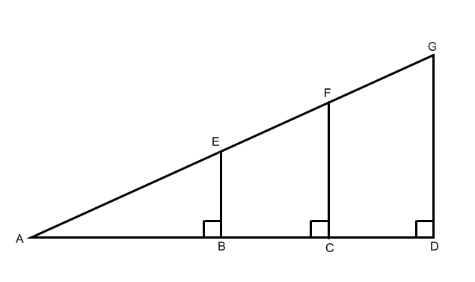

Use the figure below to answer the following questions.

$∆ABE and ∆ACF and ∆ADG$ are similar triangles. What are similar triangles?

Measure the following sides and then calculate the last column. Express each measurement to the nearest millimeter (tenth of a centimeter).

EB = | AB = | $$\frac{EB}{AB}=$$
FC = | AC = | $$\frac{FC}{AC}=$$
GD = | AD = | $$\frac{GD}{AD}=$$

What do you notice about the ratios in the last column?

