**Name: _________**

**Math 10C Final Exam**

**Part A: Multiple Choice**

1. 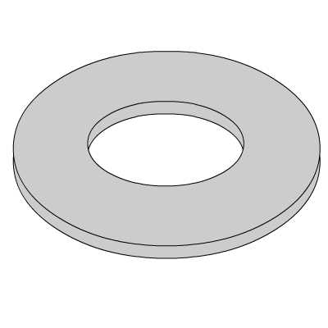Which of the following is the most appropriate for measuring the inside diameter of a washer.
   1. Trundle Wheel
   2. Tape Measure
   3. Ruler
   4. Caliper

**NUMERICAL RESPONSE**

1. Use a ruler to determine the perimeter of the object shown below. Record you answer in centimeters to the nearest tenth.
2. Which of the following is the shortest?
   1. 32 inches
   2. 85 cm
   3. 2.5 feet
   4. 0.8 m
3. Cindy and Victor are from the United States and are travelling in Canada. Their speedometer reads their speed at 55 miles/hour. The posted speed limit is 85 km/hour. An RCMP officer pulls them over. Which of the following scenarios is most likely to occur?
   1. Cindy and Victor are more than 5km/h over the speed limit, so the officer gives them a ticket.
   2. Cindy and Victor are speeding but are within 5 km/h of the speed limit, so the officer lets them go with a warning.
   3. Cindy and Victor are not speeding but are within 5 km/h of the speed limit, so the officer lets them go.
   4. Cindy and Victor are not speeding and are well below the speed limit, so the officer gives them a ticket for holding up traffic.
4. Nancy has 7 yards of fabric. She wants to make curtains that are 18 inches wide. How many curtains can Nancy make?
   1. 0.3
   2. 2.5
   3. 4.7
   4. 14
5. 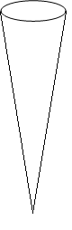Which of the objects shown at the right will hold more?

15 in

* 1. The cylinder holds more.

5 in

4 in

* 1. The cone holds more.
  2. They cylinder and cone hold the same amount.
  3. None of the Above

4 in

1. What is the diameter of a sphere with a surface area of 121 square centimeters?
   1. 9.6 cm
   2. 6.2 cm
   3. 4.8 cm
   4. 3.1 cm
2. The surface area of a cube is 864 cubic inches. Determine the volume of the cube.
   1. 25 396 in³
   2. 1728 in³
   3. 864 in³
   4. 144 in³



1. Calculate the volume of the right square pyramid to the nearest foot.
   1. 175 ft³
   2. 163 ft³
   3. 58 ft³
   4. 54 ft³
2. Calculate the surface area of the right square pyramid to the nearest square foot.
   1. 165 ft²
   2. 95 ft²
   3. 90 ft²
   4. 54 ft²
3. Determine the measure of angle D.
   1. 20.9°
   2. 22.4°
   3. 67.6°
   4. 69.1°

10 cm

55°

1. Determine the perimeter of this isosceles triangle shown at the right.
   1. 15.8 cm
   2. 21.4 cm
   3. 27.4 cm
   4. 44.8 cm
2. Two trees are 55 yards apart. From a point halfway between the trees, the angles of elevation to the tops of the trees are measured. What is the height of each tree to the nearest yard?
   1. 33 yd, 31 yd
   2. 19 yd, 15 yd
   3. 41 yd, 50 yd
   4. 49 yd, 57 yd

**NUMERICAL RESPONSE**

1. Determine the greatest common factor of 84, 210, and 336?
2. Which of the following numbers is rational?
   1. π
$\sqrt{5.76}$

$\sqrt{17}$

$\sqrt[3]{-9}$

3. Write $\sqrt{72}$ as a mixed radical in simplest form.
$8\sqrt{9}$

$6\sqrt{2}$

$3\sqrt{8}$

$2\sqrt{6}$

4. Express $a^{\frac{2}{3}}$ as an equivalent radical.
$\sqrt[2]{a^{3}}$

$\sqrt[3]{a^{2}}$

$\frac{2a}{3}$

$3\sqrt{a^{2}}$

5. Which of the following is equivalent to $b^{-3}$?

$b^{3}$

$-3b$

$\frac{b}{3}$

$\frac{1}{b^{3}}$

**NUMERICAL RESPONSE**

1. Evaluate $\frac{2^{-2}∙2^{-4}∙2^{-3}}{2^{5}∙{\left(2^{-2}\right)}^{7}}$.
2. Expand $3s^{2}t(-2s+4t^{3}-5)$.
$-6s^{3}t+12s^{2}t^{4}-15s^{2}t$

$-6s^{3}t+12s^{2}-5$

$-6s^{3}t+4t^{3}-5$

$-6s^{3}t+4s^{2}t^{4}$

3. Expand ${\left(k-8\right)}^{2}$.
   1. 
$k^{2}-64$

$k^{2}+64$

$k^{2}-8k+64$

$k^{2}-16k+64$

4. Determine the volume of the prism.
$10r^{3}+35r^{2}-93r-90$

$10r^{3}+53r^{2}-3r-90$

$10r^{3}+53r^{2}+33r-90$

$10r^{3}-90$

5. Which of the following expressions cannot be factored?
$x^{2}-6x+8$

$4x^{2}-25y^{2}$

$x^{2}-5x-14$

$x^{2}+x-13$

6. Write the expression ${6x}^{2}+17x+5$ in factored form?
$\left(6x+1\right)(3x+5)$

$\left(3x+5\right)\left(2x+1\right)$

$\left(3x+1\right)\left(2x+5\right)$

$\left(2x-5\right)(3x-1)$

7. Write the expression $-2x^{3}-2x^{2}+24x$ in factored form?
   1. 
$-2x\left(x+6\right)(x-4)$

$-2x\left(x-6\right)\left(x+4\right)$

$-2x\left(x+4\right)(x-3)$

$-2x\left(x-4\right)(x+3)$

8. State the range of the function using set notation.
$\left\{y | y≤18, y∈R\right\}$

$\left\{y | y∈R\right\}$

$\left\{y | y≥18, y∈R\right\}$

$\left\{y | -1≤y≤5, y∈R\right\}$

9. Which scenario can be represented by a continuous relation?
   1. The cost of purchasing juice boxes by the case.
   2. The number of legs in the school cafeteria as students enter for lunch.
   3. The cost of purchasing gasoline by the liter.
   4. The shoe sizes of everyone in a grade 10 mathematics class.
10. Steve starts walking to a friend’s house and gradually increases his speed until he gets there. After visiting for a short time, Steve and his friend start walking back to Steve’s house. On the way, they meet up with a third friend. The three boys continue to walk at a slower pace. When Steve realizes that he is late, he starts walking at a faster constant rate until he gets home. Which distance-time graph represents this situation?
    1. 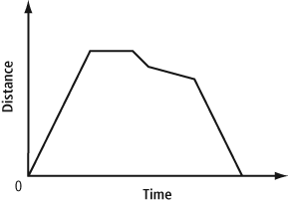
    2. 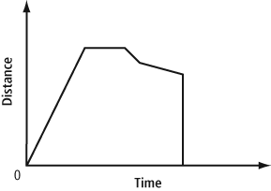
    3. 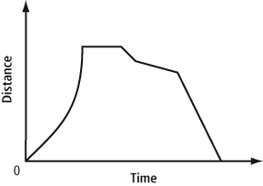
    4. 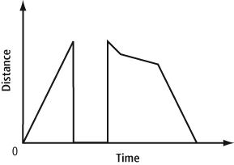
11. Which statement is **NOT** true?
    1. All relations are functions.
    2. All functions are relations.
    3. A relation is a function if each value in the domain corresponds to exactly one value in the range.
    4. Each function has its own rule that is often given using function notation.
12. 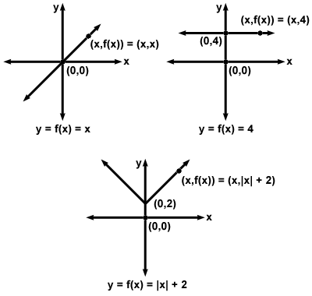Which of the following graphs is **NOT** a function?
    1. 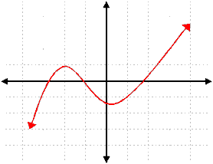

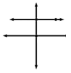

* 1. 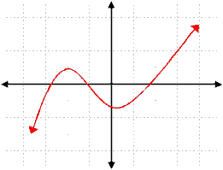

1. Which line segment has a slope of $\frac{7}{4}$?



**NUMERICAL RESPONSE**

1. Determine the slope of a line that passes through G(-3, -3) and H(5, 7). Write the slope as a decimal value.

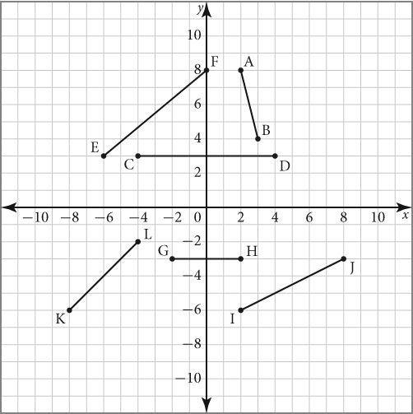

1. Which of the following statements is true?
   1. A line that is perpendicular to CD would have a slope of 0.
   2. A line that is perpendicular to AB would have a slope of $-\frac{1}{4}$.
   3. Lines EF and KL are parallel.
   4. A line that is parallel to IJ would have a slope of $\frac{1}{2}$.
2. The cost of a taxi ride is $5 plus $0.75 for every half a kilometer. Which graph represents this relation?
   1. 
   2. 
   3. 
   4. 
3. Identify which of the following relations is linear.
 $\left\{\left(1, 1\right), \left(2, 4\right), \left(3, 9\right), (4, 16)\right\}$

 $C=πd$

 1. One variable is the cube of another variable.
   2. 
$y=2x^{2}-4$

4. Determine the *x* and *y*-intercept of the graph shown at the right.
   1. (-3, 0) and (0, -3)
   2. (3, 0) and (0, -3)
   3. (0, 3) and (-3, 0)
   4. (3, -3) and (-3, 3)

**NUMERICAL RESPONSE**

1. Determine the *x*-intercept of the relation $2x+4y=12$. Record the *x*-value on your answer sheet.
2. Which of the following graphs has a slope of -3 and a *y*-intercept of 4?
   1. 



1. Write the equation $x+2y+10=0$ in slope-intercept form.
$y=-\frac{1}{2}x-5$

$y=-\frac{1}{2}x+5$

$y=\frac{1}{2}x-5$

$y=\frac{1}{2}x+5$

2. Which is the equation of the line shown at the right?
   1. 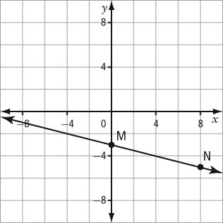 $y=-4x-3$
$y=-\frac{1}{4}x-3$

$y=\frac{1}{4}x-3$

$y=4x-3$

3. Which of the following is the equation of the line shown at the right written in general form?
$4x+y+3=0$

$x+4y+3=0$

$4x+y+12=0$

$x+4y+12=0$

4. What is the equation of a line that has a slope of $-\frac{1}{2}$ and a *y*-intercept of 3?
$y=-2x-3$

$y=-\frac{1}{2}x+3$

$y=\frac{1}{2}x+3$

$y=-\frac{1}{2}x-3$

5. What is the equation of a line that passes through (2, 9) and (-1, 3)?
$y=-2x+1$

$y=-2x+5$

$y=2x+1$

$y=2x+5$

6. A student made the following statements about the line with the equation $2y=5x+12$.

**Statement 1:** The line has a slope of 5.

**Statement 2:** The line is parallel to $10x-4y+13=0$.

**Statement 3:** The line passes through (-2, 1).

Which of the above statement(s) is/are true?

* 1. 1 and 2 only
  2. 1 and 3 only
  3. 2 and 3 only
  4. 1, 2, and 3

1. Evaluate $f(-4)$ for the function $f\left(x\right)=x^{2}-5x+2$.
   1. -2
   2. 6
   3. 30
   4. 38
2. The graph to the right represents the function $g(x)$. What is the value of *x* for which $g\left(x\right)=-2$?
   1. 2
   2. 1
   3. -1
   4. -2
3. A function is given by $h\left(x\right)=-4x+5$. If the domain of the function is $\left\{-2, -1, 0, 1, 2\right\}$, what is the range?
$\left\{13, 9, 5, 1, -3\right\}$

$\left\{-3, 1, 5, 9, 13\right\}$

$\left\{-13, -9, -5, -1, 3\right\}$

$\left\{3, -1, -5, -9, -13\right\}$

4. Determine the number of solutions of the linear system
$$5x+7y=76$$

$$-25x-35y=-380$$

5. No Solutions
6. One Solution
7. Infinite Solutions
8. None of the Above
9. Determine the solution for the system of equations.

$$y=2x-2$$

$y+2x-6=0$

1. (2, 2)
2. (2, 6)
3. There is no solution.
4. There are infinite solutions.

**NUMERICAL RESPONSE**

1. KC Fitness Club charges a flat fee of $25 a month plus $5 per visit. Workout Zone charges a flat fee of $35 a month plus $3 per visit. After how many visits is the cost of Casey Fitness Club and Workout Zone equal?

Name: ___________________

**Math 10C Final Exam**

**Part A: Multiple Choice & Numerical Response**



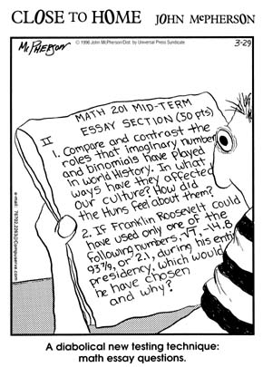

Senteo #9 Senteo #10

**Congratulations! You have just completed Math 10C!**