Let’s Physics!!!!!!!!!!!

1. Does This Make Any Cent?
$1 = 100¢
= 10¢ x 10¢
= $(1/10) x $(1/10)
= $(1/100)
= 1¢

2. The Eiffel Tower has a mass of 10,000,000 kg. A 100:1 scale model of the tower made from the same material will have a mass of
(A) 100,000 kg
(B) 10,000 kg
(C) 1,000 kg
(D) 100 kg
(E) 10 kg
(F) 1 kg
3. The paths crossed for three men -- A, B, and C -- walking through woods. It was a cold night. They decided to light a fire and rest by it for the night. They set out to bring some firewood. A came back with 5 logs of wood, B brought 3 logs, but C came back empty-handed. C requested that they let him rest by the fire and promised to pay them some money in the morning. In the morning C paid them $8. How should A and B split the money fairly?
(A) A $7; B $1
(B) A $6; B $2
(C) A $5; B $3
(D) A $4; B $4
(E) None of these
4. Scaling a Wall. An insect is climbing up a 30 ft. vertical wall. Starting from the bottom, the insect climbs up 3 ft. during the day and slips down 2 ft. during the night. In how many days will the insect reach the top of the wall?
(A) 31 days
(B) 30 days
(C) 29 days
(D) 28 days
(E) 27 days
(F) Never
5. Where on Earth Is This Person? A person somewhere on the earth travels 10 mi. south, then 10 mi. east, and then 10 mi. north. He is back at his starting point. Which place on the earth is he?
6. Hiker Up and Down the Hill. A hiker started to climb up the hill at 6:00 a.m. and either kept climbing up or rested at some place(s). He reached the top at 6:00 p.m. He rested there for the next 12 hours. Next day at 6:00 a.m., he began to travel down the same path. He either moved downward or rested at some place(s). For the up and down trips, how many times was he at the same place at the same time?
(A) Never
(B) At least once
(C) Once and only once
(D) At most once
(E) Only twice
(F) None of these
7. Playful Dog and the Master. Mr. Fiz is returning home at a speed of 2 mph with his dog Ix. He unleashes Ix when they are still 3 miles from his house. Ix happily begins running back and forth between the house and his master with a constant speed of 3 mph. Ix does not waste any time while turning around. By the time Mr. Fiz reaches home, how many miles has Ix run?
(A) 3.5 miles
(B) 4.0 miles
(C) 4.5 miles
(D) 3.333...miles
(E) 3.555...miles
(F) None of these
8. Average Round-Trip Speed. A person travels from city A to city B with a speed of 40 mph and returns with a speed of 60 mph. What is his average round-trip speed?
(A) 100 mph
(B) 50 mph
(C) 48 mph
(D) 10 mph
(E) None of these
9. Two Trains. Two trains are moving toward each other with speeds of 17 mph and 43 mph. How far apart are they 1 minute before they pass each other?
(A) 60 miles
(B) 30 miles
(C) 6 miles
(D) 3 miles
(E) 2 miles
(F) 1 mile
10. And The Winner Is... Two marbles roll along two horizontal tracks. One track has a dip, and the other has a bump of the same shape. Which marble wins?
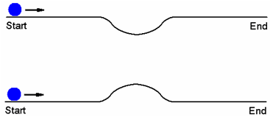
11. Time of Flight of Three Projectiles. Three projectiles are launched from the same point over a level ground with speeds V_{A}, V_{B}, and V_{C}. They all attain the same maximum height. Which of the following is true about their times of flight?
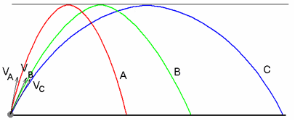
(A) t_{A} = t_{B} = t_{C}
(B) t_{A} > t_{B} > t_{C}
(C) t_{A} < t_{B} < t_{C}
(D) None of these
12. Initial Speeds of Three Projectiles. Three projectiles are launched from the same point over a level ground with speeds VA, VB, and VC. They all attain the same maximum height. Which of the following is true about their initial speeds?
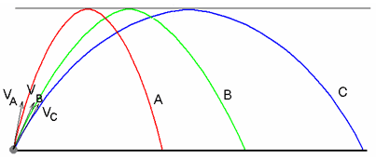
(A) V_{A} = V_{B} = V_{C}
(B) V_{A} > V_{B} > V_{C}
(C) V_{A} < V_{B} < V_{C}
(D) None of these
13. Speed of a Projectile and the Angle of Launch. A ball is launched from the same height repeatedly with the same speed V_{o} but in different directions A, B, and C as shown below. It reaches the ground with speeds V_{A}, V_{B}, and V_{C} respectively. Which of the following is true about these speeds?
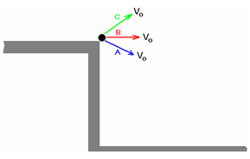
(A) V_{A} = V_{B} = V_{C}
(B) V_{A} > V_{B} > V_{C}
(C) V_{A} < V_{B} < V_{C}
(D) None of these

