Math 10 Name: ________________________

Slopes of Graphs Date: _________________________



1. Determine the slope between the following points
2. A(-3, 6) and B (9, 16) b. C(5, 3) and D(-6, 3)

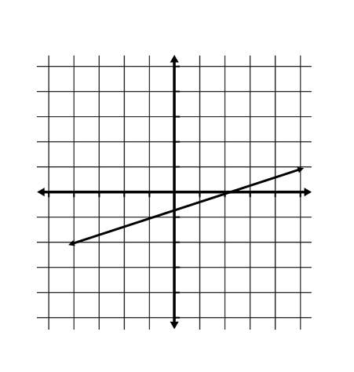

c.

|  |  |
| --- | --- |
| X | y |
| 2 | 10 |
| 4 | 6 |
| 6 | 2 |

d.

1. Given that lines segment XY has a slope of , what is the slope of a line that is
   1. Parallel = ___________
   2. Perpendicular = _________
2. For the following sets of points determine if they are parallel, perpendicular, or neither.
   1. Line ST through S(-2, 7) and T(2, -5). Line UV through U(-2, 3) and V (7, 6)
   2. Line AB through A(1, 6) and B (5, 4). Line CD through C(-2, 1) and D (4, -2)