**10C – M3 V3 Measurement – Surface Area & Volume**

**Part I:**

1. 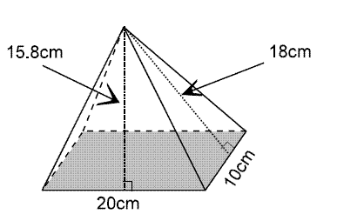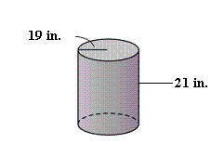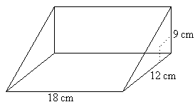Calculate the surface area.
2. Calculate the volume.
   1. 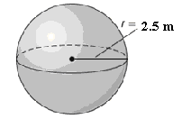
   2. 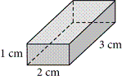

**Part II:**

1. How much more air is needed to fill a basketball with a diameter of 9 inches than a volleyball with a diameter of 8.4 inches?
2. Nicole has a cone with a radius of 8 cm and a lateral area of 414.5 cm². She needs a cone with a height of at least 15.5 cm for a craft project.
   1. Is this cone tall enough? Justify your answer.
   2. Determine the volume of the cone.
3. Thomas has a coin container in the shape of a cube that measures 6 cm by 6 cm by 6 cm. He has placed 80 coins in it, each with a radius of 1.2 cm and a thickness of 2 mm. How much space inside the coin container is unoccupied by the coins?

**Part III:**

1. A sphere has the same volume as that of a right cone. The cone has a radius of 8 cm and a height of 12 cm. What is the radius of the sphere?