10C – RF5 V2 Relations & Functions – Graphs of Linear Relations

Part I:
x | y
-10 | 0
-5 | -2
0 | -4
5 | -6
10 | -8
- Determine the following characteristics of the linear relation.
  - x-intercept

  - y-intercept

  - slope

  - domain

  - range

Part II:
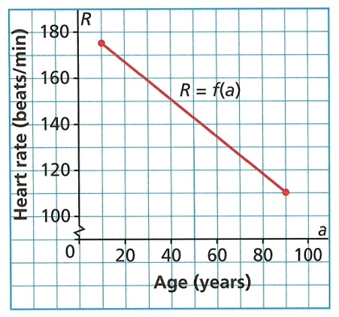
- This graph shows the recommended maximum heart rate of a person as a function of his/her age for a stress test.
  - Why are there no intercepts for this graph?

  - What is the rate of change? What does it represent?

  - State the domain and range.

Part III:
- For the relation $y=x^{2}+3:$
  - Determine the x and y-intercepts.

  - State the domain and range.

