***Pre-Calculus 11***

***Year in Review***

***Unit I – Sequences and Series***

***Calculator Section***

1. Given the arithmetic sequence  determine:
2. the common difference b) the 5th term c) the partial sum 
3. Given the arithmetic sequence  determine:

a) the common difference b) the 8th term c) the partial sum 

1. Given the arithmetic series with first term –3 and common difference 4, determine.
2. Given the arithmetic series , determine the sum of the first 14 terms.
3. If an arithmetic series has  and , then determine the common difference.
4. In an arithmetic sequence, the 5th term is 12 and the 8th term is 18.9. Determine the common difference of this sequence.
5. Which term in the arithmetic sequence  is 19.8?
6. Given that an arithmetic series has  and , determine the common difference.
7. How many terms are in the series given by 
8. Determine the common ratio of the geometric series: 
9. Calculate the 7th term of the geometric sequence: 8000, 4000, 2000, ...
10. If the sum of the first 5 terms of a geometric series is –328 and the common ratio is –4, determine the first term.
11. Evaluate 
12. Find the sum of the infinite geometric series 160 – 40 + 10 – …
13. Determine all possible values of ***k*** in the geometric sequence 2, ***k***, 18…
14. Determine the second term of the series given by
15. Determine the fourth term in the geometric sequence 8*x*, 4*x*2,
16. The sum of an infinite geometric series is 27, and the first term is 18, determine the common ratio.
17. Determine the partial sum of the arithmetic series with and last term 
18. Given the arithmetic series 

a) Determine the 6th term.

1. Which term in the series is ?
2. Determine an expression for the partial sum  of this series.
3. If the 4th term of the series is –12, then determine the common difference.

***Unit II – Absolute Value and Radicals***

***Non-Calculator Section***

1. Evaluate:

a)  b)  c) 

1. Evaluate  for when 
2. Write the following as an entire radical:
3.  b) 
4. Which of the following is the largest: 
5. For which values of the variable is the radical  defined?
6. For which values of the variables is the expressions  defined?
7. Write the entire radical as a mixed radical.
8.  b) 
9. Write the mixed radical as an entire radical.

a)  b) 

1. Simplify:

a)  b) 

1. Expand and simplify:

a)  b)  c) 

1. Rationalize the denominator and simplify the expression:

a) . b)  c) 

d)  e)  f) 

1. Solve the following:

a)  b)  c) 

d)  e)  f) 

***Calculator Section***

1. A square with area 20 square units is placed beside a square with area 36 square units. In simplest form, write a radical expression for the perimeter of the shape formed.

***Unit III – Solving Quadratic Equations***

1. Factor the following:
2.  b)  c) 

d)  e)  f) 

g)  h)  i) 

1. Solve the following:
2.  b)  c) 

d)  e)  f) 

g)  h)  i) 

1. Solve for *x* exactly by completing the square:
2.  b)  c) 
3. A young lad shoots off a model rocket. The height *h*, in meters, of the rocket off the ground is given by the formula , where *t* is the time in seconds after the rocket is launched. Determine how long it takes for the rocket to reach a height of 20*m*.
4. When two times a number is subtracted from the square of the number, the result is 35. Determine the number.
5. Carla Carlson's rectangular emu pen measures 5*m* by 7*m*. When she increases both dimensions by the same amount, the area of the pen increases by 45*m2*. Determine the dimensions of the larger pen.

***Unit IV – Quadratic Functions***

1. Given the general form quadratic function, convert the equation to standard form, then determine the coordinates of the vertex, the axis of symmetry, the range, and graph the parabola.
2.  b)  c) 
3. Given the general form quadratic function, use the factor/intercept method to determine all the intercepts, and the coordinate of the vertex.
4.  b) 
5. Determine the general form quadratic function, with integer coefficients, given the following:
6. zeros: , passing through the point 
7. vertex: , with *y*-intercept of –1
8. one of the zeros at, and with vertex 
9. 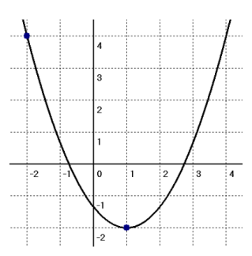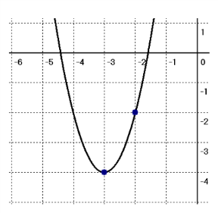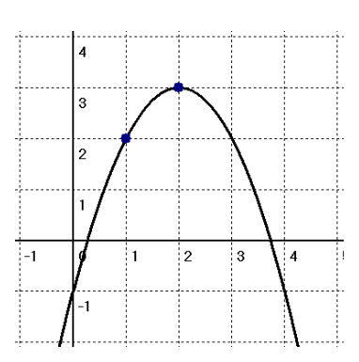Given the following graphs, determine the standard form quadratic function.
   1. b) c)
10. Lenny Leonardson can sell his ostrich eggs for $20 an egg, and he will sell 120 eggs a year. He estimates that for each $2 increase in the price of the egg, he will sell 5 less eggs per year. How much should Lenny charge per egg to maximize his revenue?
11. Determine two consecutive odd integers such that the sum of their squares is a minimum.
12. A T-shirt company sells its shirts for $20 each and sold 1200 shirts last month. For each $2 increase in the price of a T-shirt, the manager estimates she will sell 60 fewer shirts each month. At what price should the manager sell T-shirts to maximize the revenue?
13. A farmer with 1200m of fencing wants to enclose a rectangular area and then divide it into four pens with fencing parallel to one side of the rectangle. What is the largest possible total area of the four pens?

***Unit V – Systems of Equations***

1. Solve the following quadratic inequality and give your answer as an inequality.
   1.  b)  c) 
2. 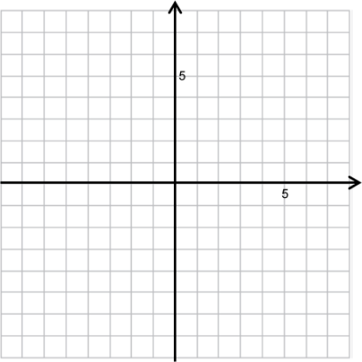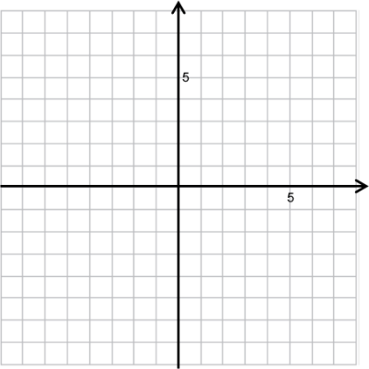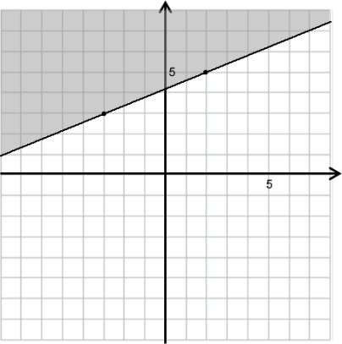Write an inequality to describe each of the shaded regions.
   1. b) c)
3. Graph each inequality.
   1.  b)  c) 
4. Solve the following systems of equations algebraically (answers accurate to 2 decimals).
   1.  b)  c) 

***Unit VI – Trigonometry***

***Non-Calculator Section***

1. Draw the following angles in standard position, determine the reference angle, and then find the given trigonometric ratio using the reference angle and the CAST rule.

a)  b) c) d)

1. Solve for ***x*** exactly, if .

a)  b)  c)  d) 

1. If , and , then determine the exact value of .
2. If , and , then determine the exact value of .
3. Determine in which quadrant the following terminal arms lie given the following information.

a) , and  b) , and 

***Calculator Section***

1. Solve for  to 1 decimal place, if . There should be two answers.

a)  b)  c)  d) 

1. Solve for *x*, :

a)  b)  c) 

1. Elli and Helmut are standing 95*m* apart. They both observe a bird perched at the very top of a tree that stands between them. Elli's angle of elevation to the bird is 40°, whereas Helmut's angle of elevation is 27°. How tall is the tree?
2. For each of the following, use the cosine and sine laws to solve the triangles (find all missing sides and angles). Lengths accurate to 2 decimals, and angles accurate to the nearest degree.
   1. 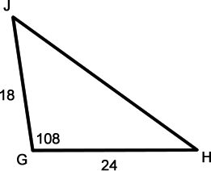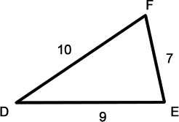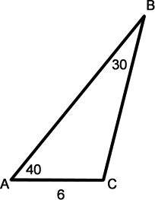 b) c)











***Unit VII – Rationals***

* + - 1. Simplify the following rational expressions.

a)  b)  c) 

d)  e)  f) 

g) 

2. Solve each equation.

1.  b)  c) 

d)  e)  f) 

1. Suppose Lenny Leonardson can paint his entire ostrich barn in thirteen hours, and when Carla Carlson helps it takes six hours. How long would it take for Carla to paint the barn on her own?
2. Lenny and Carla agree to meet at the "Big Bird Auction" in Vancouver over the weekend. Lenny travels 104km in the same time that Carla travels 96km. If Lenny's rate of travel is 4km/h more than Carla's, at what speed does Lenny travel?
3. The speed of a stream is 3km/h. If a boat travels 115km downstream in the same time that it takes to travel 85km upstream, what is the speed of the boat in still water?
4. How much sand should be added to 50L of topsoil, if the mix should be 23% sand by volume?

***Unit VIII – Absolute Value and Reciprocal Functions***

1. Sketch a graph of the following absolute value functions.

* 1.  b)  c) 

d)  e)  f) 

1. Determine the piece-wise equation for each of the absolute value functions in question #1.
2. Determine a possible equation for each of the following absolute value graphs.



* 1.  b)

1. Solve each equation algebraically.
   1.  b)  c) 

d)  e) 

1. Graph the following functions, and determine the equations of any vertical asymptotes.
   1.  b)  c) 
2. 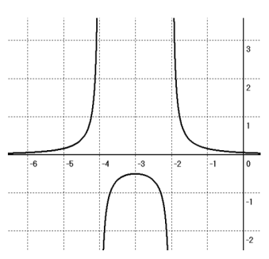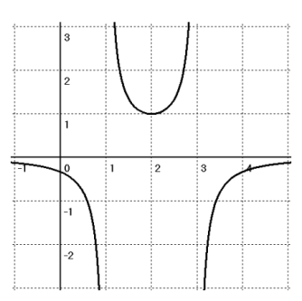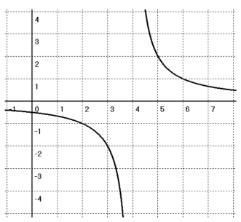Given that the graph is the reciprocal of either a linear function or a quadratic function, determine its equation.
   1. b) c)

